# Riphah International University Lahore, Pakistan



**Riphah School of Computing & Innovation**

## FINAL YEAR PROJECT

**PROJECT PROPOSAL & PLAN**

# Cultureup

Project ID: **[Issued by FYP Manager]**

**Project Team**

|  |  |  |  |  |
| --- | --- | --- | --- | --- |
| **Student Name** | **Student ID** | **Program** | **Contact Number** | **Email Address** |
| Shayan Shuaib | 28880 | BSCS | 03224808042 | 28880@students.riphah.e  du.pk |
| M. Shoaib Shoukat | 28913 | BSCS | 03110696252 | 28913@students.riphah.e du.pk |
| Mohsin Raza | 37953 | BSCS | 03212124005 | [razach1932@gmail.com](mailto:razach1932@gmail.com) |
|  |  |  |  |  |
|  |  |  |  |  |

**Supervised By : Ma’am Saadia Aziz**

# Cultureup

**Change Record**

|  |  |  |  |  |
| --- | --- | --- | --- | --- |
| **Author(s)** | **Version** | **Date** | **Notes** | **Supervisor’s Signature** |
|  | 1.0 |  | Original Draft |  |
|  | 1.1 | 17 March | Feedback from Supervisor | Ma’am Saadia |
|  | 1.2 | 20 March | Changes Based on Feedback from Supervisor | Ma’am Saadia |
|  |  |  | Changes Based on Feedback From Faculty |  |
|  |  |  | Added Project Plan |  |
|  |  |  | Changes Based on Feedback from Supervisor |  |
|  |  |  |  |  |
|  |  |  |  |  |

# Project Proposal

**Project Title: Cultureup**

### Executive Summary

Cultureup.pk is Pakistan’s first freelancing and e-commerce platform dedicated to artists, providing them with a space to showcase their work, gain exposure, and earn appreciation. It’s a hub for unique, handcrafted, and vintage treasures from around the world.

## Introduction:

**Cultureup.pk** is Pakistan’s first dedicated freelancing and e-commerce platform for artists. No more hiding your art in dusty cupboards—bring it to life and share it with the world. Cultureup.pk offers artists the exposure, appreciation, and business opportunities they truly deserve. Whether you're into painting, interior design, or digital art, this is your creative home.

Unlike other platforms, **Cultureup.pk** introduces a **bidding system** where buyers can post jobs and artists can bid based on their skills—making project acquisition dynamic and fair.

Key features include:

* **Login/Signup** for personalized access
* **Direct messaging** between artists and clients for clear communication
* **Sell your artwork** freely with **no limit** on uploads
* Access to essential **equipment** like frames, paints, and brushes
* **Image security** with pixelation and cross-platform **image comparison** to avoid plagiarism
* **Custom contracts** defining rights (e.g., display only, reproduction rights) for secure transactions
* Built-in **art protection** tools: disable right-click/drag and embed **watermarks or artist signatures**

Cultureup.pk isn’t just another freelancing platform—it’s a complete ecosystem built around artists’ needs, blending creativity with security and opportunity.

1. **Existing System / Competitive Analysis**

|  |  |  |  |  |  |
| --- | --- | --- | --- | --- | --- |
| **Feature** | **Cultureup** | **EJAZ Art**  **Gallery** | **Artsoch** | **Ocean Art**  **Gallery** | **Oartspace** |
| Login/Signup  System | ✅ | ✅ | ❌ | ❌ | ❌ |
| Art Selling | ✅ | ✅ | ❌ | ❌ | ❌ |
| Direct Client Communication | ✅ | ❌ | ❌ | ❌ | ❌ |
| WhatsApp Contact | ❌ | ❌ | ❌(not artists  directly) | ❌ | ❌ |
| Equipment Provided | ✅ | ❌(only wooden frames, not  purchasable) | ❌ | ❌ | ❌ |
| Artwork Upload  Limit | (20 paintings limit) | Not specified | (10 paintings limit) | Not specified | Not specified |
| Auction/Bidding | ✅ | ❌ | ❌ | ❌ | ❌ |
| Review System | ✅ | ❌ | ❌ | ❌ | ❌ |
| Direct Hiring | ✅ | ❌ | ❌ | ❌ | ❌ |
| Hidden Fees | ❌ | ❌ | ❌ | ❌ | ❌ |
| Payment System | ✅Instant | ✅ | ❌ | ❌ | ❌ |
| Community & Networking | ✅ | ❌ | ❌ | ❌ | ❌ |

### References

1: Oart space

<https://oartspace.com/> 2: Ocean galleries

<https://oceangalleriespk.com/> 3: Ejax art gallery

<https://ejazartgallery.com/> 4: Art Soch

<https://artsoch.com/>

## Problem Statement:

Nowadays, in our country the encouragement of art is little to none. There is a limited scope of art, we buy art to decorate it but don’t recognize the efforts behind it. That's why artists have to change their field in order to sustain themselves in society. We are providing a platform that will change the art industry in our county. Our platform will provide artists an easy and safe way to monetize their talent. Artists will no longer have to change their field to earn and encourage them to be proud of their talent and make a mark in the art industry.

* **Assumptions & constraints**
* The project must be completed within the given period
* Admin must be aware of the application
* Admin can log in only with registered email
* The Artist can bid on a Job after completing his/her profile
* Artist should have decent internet services

## Proposed Solution:

Focus of the project is to create a platform to connect artists and customers from anywhere around the country. Cultureup.pk is designed to solve problems involved in the traditional system as well designed for online use so that artists get recognition and earn from their skill. This system is designed for:

* Helping traditional businesses in switching to Online Mode
* Providing a User-friendly and interactive environment to both the sellers and the buyers
* Excellent response time
* Accessibility to artists from anywhere around Pakistan
* Can be Accessed at any time

Cultureup.pk helps in several ways, increasing the importance of Art and people related to it.

## Scope of the Project

* The main motivation behind our project is to provide an art platform to those artists who don’t have any platform to showcase their talent. In Pakistan, there are many artists who give up on their dreams and sometimes quit making art because of this reason but now they won’t be neglected because Cultureup.pk is here to lift all the artists and their morals. We will provide the best possible way for the artists where they can create their art and can earn good income with it.
* There will be a much larger scope of this application in future, and this will be only possible by educating people regarding the value of antique items and Cultureup.pk itself

## System Architectural Design

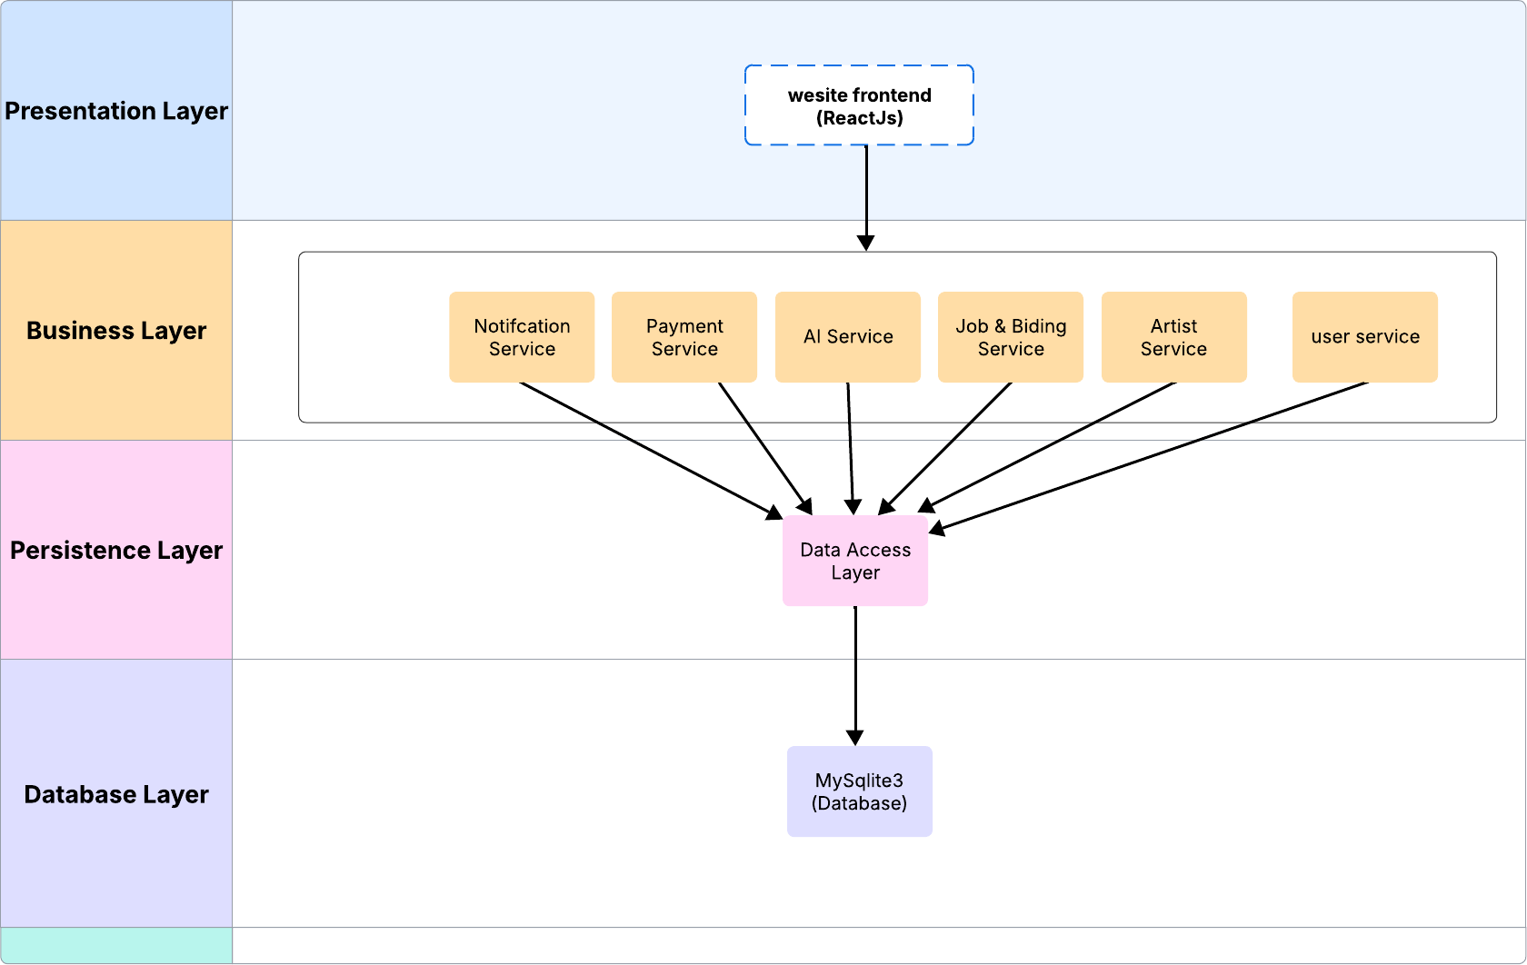

### Presentation Layer:

This layer is responsible for interacting with the end-user. It presents the user interface and collects user inputs.

### Business Layer:

This layer contains the core business logic of the application. It processes requests from the frontend, applies rules, and interacts with the persistence layer.

### Persistence Layer:

This layer acts as an intermediary between the business logic and the database. It manages all database interactions, ensuring data integrity and security.

### Database Layer:

This layer is responsible for storing and retrieving data persistently.

## Implementation Tools and Techniques:

The system architecture of **CultureUp.pk** is built on a **React.js, Python, and SQLite3** stack, ensuring a scalable and efficient development environment. The project leverages **SQLite3** as a lightweight yet powerful alternative to MySQL, providing seamless data management. For the backend, we utilize **Python with the Django framework**, ensuring robust and secure server-side operations. On the frontend, **React.js** is employed for a dynamic and interactive user experience, with **Redux** integrated as needed for state management.

### Frontend:

The Frontend will be on ReactJS.

### Backend:

The backend will be in Python.

### Database :

The database will be on SQLITE 3.

Cultureup.pk is designed to solve problems involved in the traditional system as well designed for online use so that artists get recognition and earn from their skill.

### Work Breakdown Structure

#### Project Management

* 1. Work Breakdown Structure (WBS)
     1. Define Project scope
     2. Identify project deliverables
  2. Roles & Responsibility Matrix
     1. Define project roles
     2. Assign responsibilities to roles
  3. Change Control System
     1. Establish change control procedures
     2. Implement change control procedures1.3.3. Monitor and control changes.
  4. Communication Plan

#### Requirements Gathering & Analysis

* 1. Gather Functional Requirements
     1. Identify stakeholders
     2. Document functional requirements
  2. Gather Non-Functional Requirements
     1. Identify performance requirements
     2. Identify security requirements
     3. Document non-functional requirements
  3. Analyze Requirements
     1. Prioritize requirements
     2. Validate requirements
     3. Refine requirements
  4. Document Requirements
     1. Create a requirements document
     2. Review and approve requirements document

#### Use case Analysis

* 1. Use Case Model
  2. Use Case Description

#### System Design

* 1. Define System Architecture
     1. Identify system components.
     2. Define system interfaces.
     3. Create a system architecture diagram.
  2. Design Database Schema.
     1. Identify data entities.
     2. Define data attributes
     3. Create a database schema diagram
  3. Design User Interfaces
  4. Design Data Management
     1. Identify data management requirements
     2. Define data management components
     3. Create a data management diagram
  5. Design ERD Diagram
  6. Design Data Flow Diagram
  7. Design Class Diagram
  8. Design Activity Diagram
  9. Design Sequence Diagram
  10. Design State Transition Diagram
  11. Design Domain Diagram

#### Test Case

1. **Development Environment Setup**
   1. Set Up IDE.
   2. Set Up Version Control
   3. Set Up Server
   4. Set Up Database

#### Implementation

* 1. Implement Artist Registration & Portfolio Module
     1. Define artist registration & portfolio requirements
     2. Implement artist registration & portfolio components
     3. Test artist registration & portfolio module
  2. Implement Freelancing & Bidding System
     1. Define freelancing & bidding system requirements
     2. Implement freelancing & bidding system components
     3. Test freelancing & bidding system module
  3. Implement E-Commerce & Product Listing Module
     1. Define e-commerce & product listing requirements
     2. Implement e-commerce & product listing components.

7.3.3 Test e-commerce & product listing module

* 1. Implement Secure Payment & Transaction Module
     1. Define secure payment & transaction requirements
     2. Implement secure payment & transaction components
     3. Test secure payment & transaction module
  2. Implement Artist & Buyer Communication Module
     1. Define artist & buyer communication requirements
     2. Implement artist & buyer communication components
     3. Test artist & buyer communication module

#### Testing & Performance Evaluation

* 1. Unit Testing
     1. Test individual components
     2. Identify and fix bugs
  2. Integration Testing
     1. Test system integration
     2. Identify and fix integration issues
  3. System Testing
     1. Test the entire system
     2. Identify and fix system issues
  4. Performance Evaluation
     1. Evaluate system performance
     2. Identify and fix performance issues

### Roles & Responsibility Matrix:

The purpose of roles & responsibility matrix is to identify who will do what.

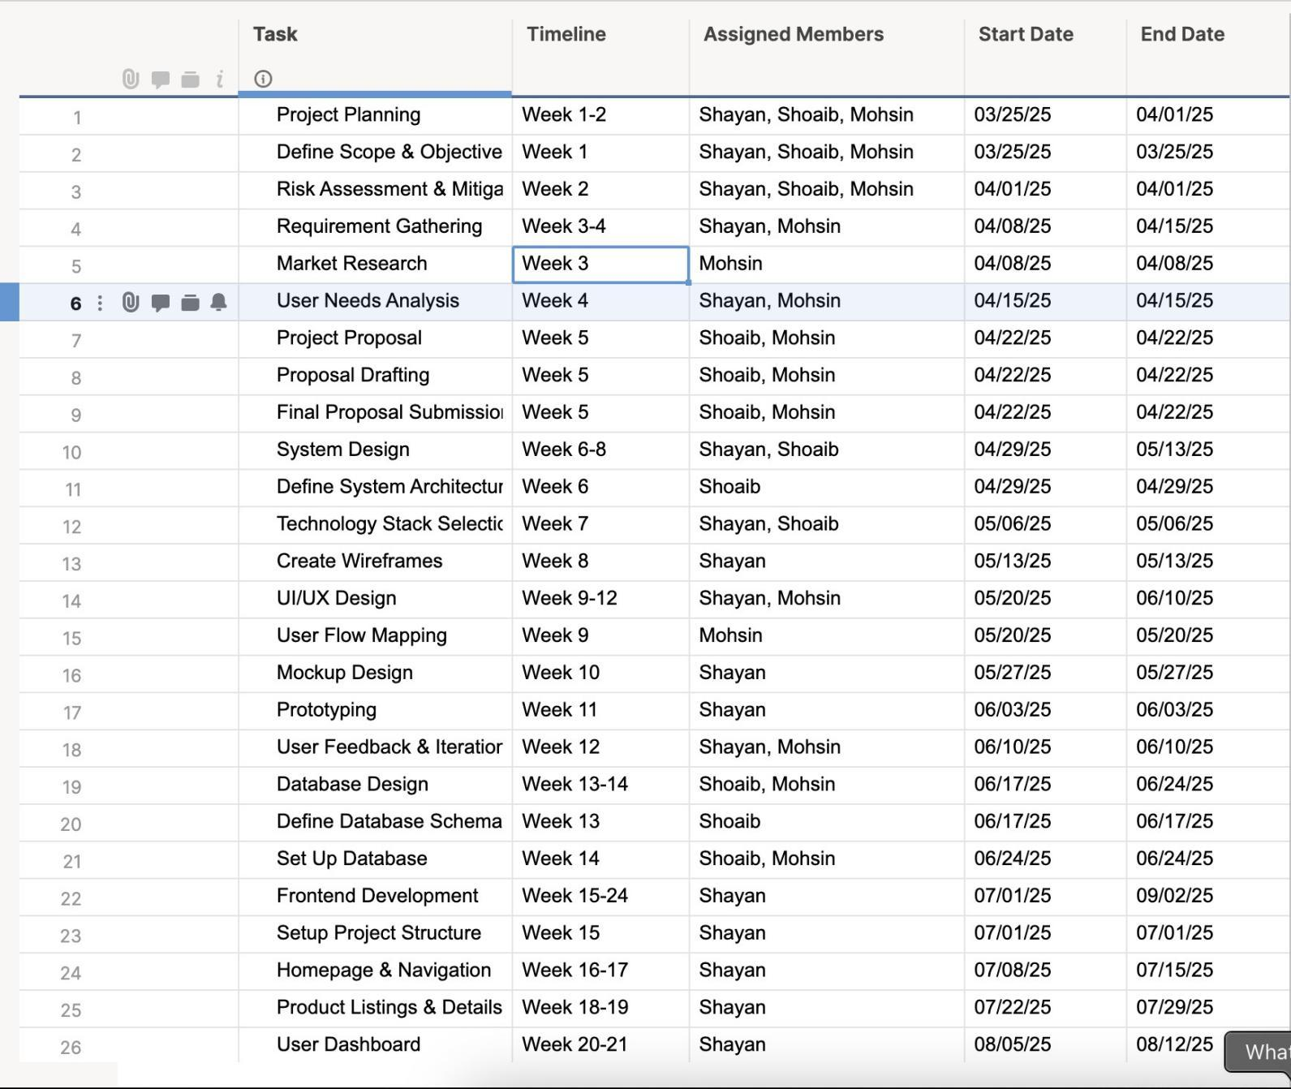

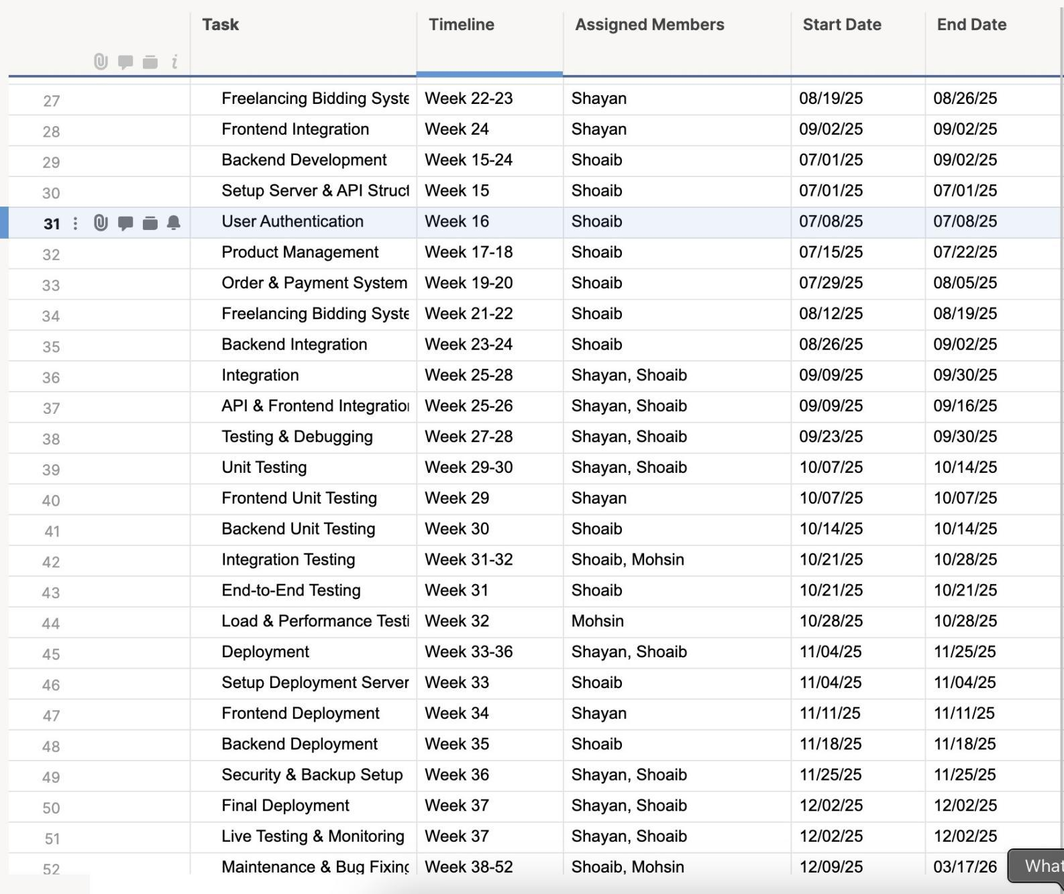

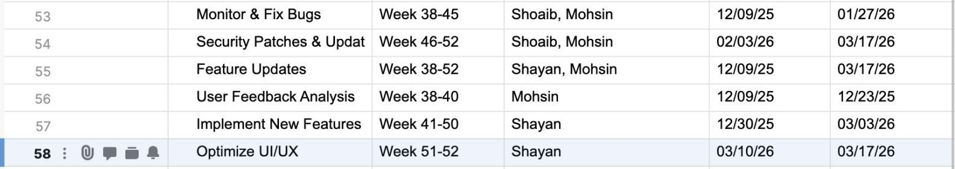

* 1. **Gantt Chart**

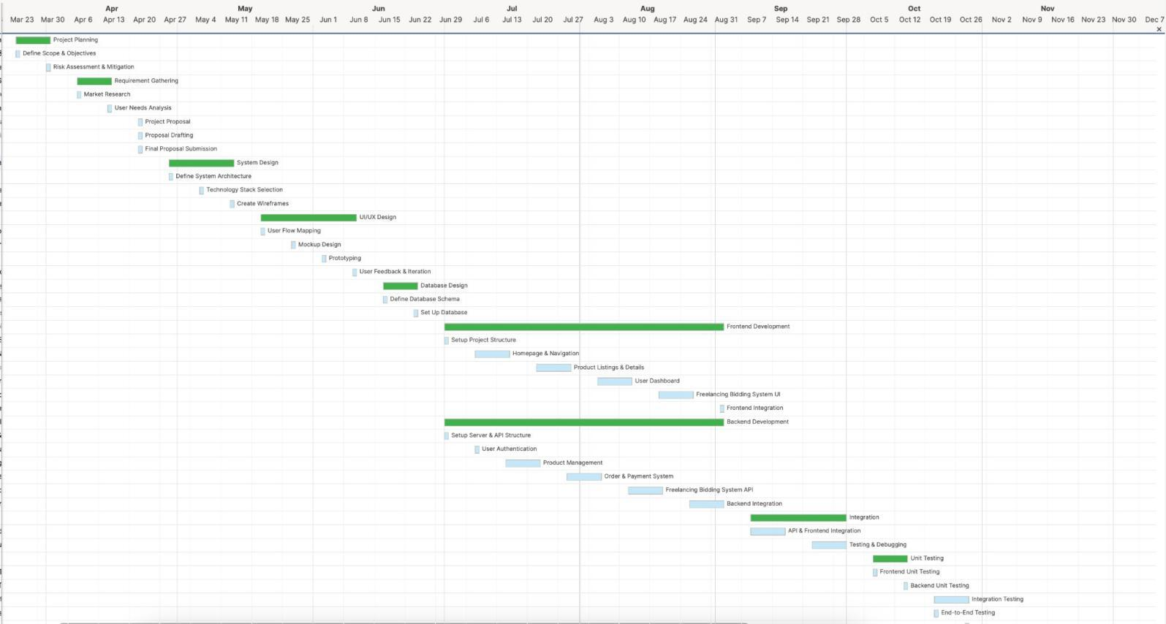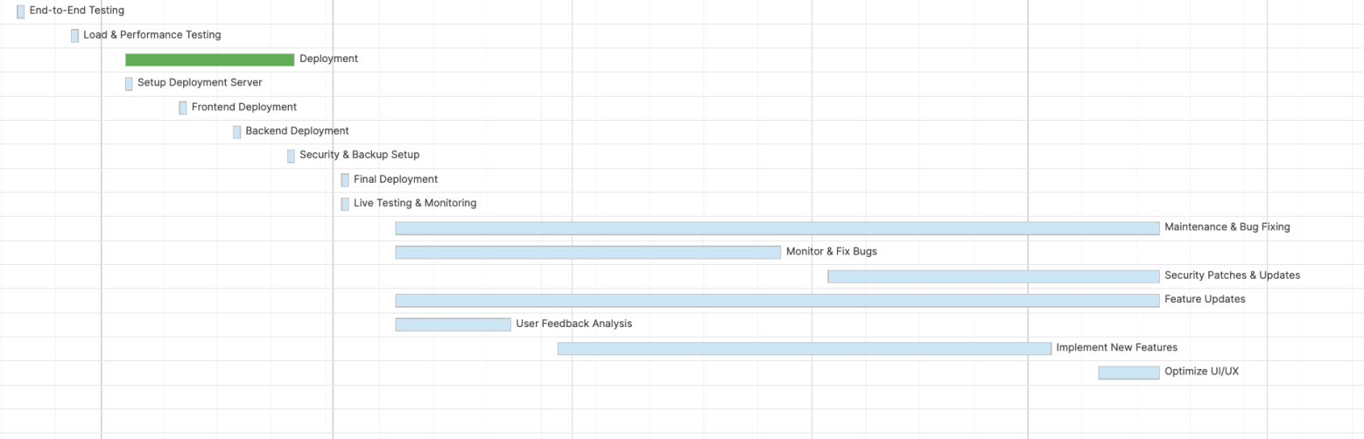

**Chapter 2: Software Requirement Specifications**

## Introduction

## Purpose

The purpose of this document is to define the software requirements for Cultureup.pk a Pakistan based freelancing and e-commerce platform exclusively for artists. This platform empowers artists to showcase, sell, and offer commissioned work in a protected, accessible digital environment.

## 

## Document Conventions

Standard typographical conventions have been followed to ensure clarity and consistency. Headings and subheadings are used to structure the content logically, while bullet points and numbered steps help in presenting detailed processes clearly. Bold text is used for emphasis on key terms or actions. No specific font-based significance is assumed beyond standard readability practices. Additionally, higher-level requirement priorities are assumed to be inherited by their respective detailed requirements unless explicitly stated otherwise. Each requirement is presented with equal importance unless marked with priority indicators in future revisions

## 

## Intended Audience and Reading Suggestions

This document is intended for the following audiences:

* Development Team (Frontend, Backend, DevOps): To understand the system requirements, features, and technical specifications for implementation.
* Product Owner and Stakeholders: To review the product scope, features, and ensure the system aligns with business goals.
* Legal and Compliance Reviewers: To verify that the system meets legal, privacy, and regulatory requirements.

Each section of the document should be read based on the reader’s role. Developers should focus on functional and non-functional requirements, stakeholders should focus on system features and scope, and compliance teams should review security and legal sections.

## Product Scope

Cultureup.pk will serve as a complete ecosystem for artists, enabling them to:

* Sell and upload art
* Bid on freelance jobs
* Communicate with clients
* Purchase essential art materials
* Secure their digital assets against plagiarism

The system will support three user roles:

* **Artists**
* **Admin**
* **Clients/Buyers**

## Overall Description

## Product Perspective

Cultureup.pk is a web-based application, accessible through desktops and mobile devices. It may also be developed into a hybrid mobile application in the future.

## Product Functions

User registration and authentication

Profile management for artists and clients

Art uploads with watermarking and protection

Direct messaging between clients and artists

Freelance job posting and bidding system

E-commerce platform for equipment

Custom contract generation

Image comparison system to detect duplicates/plagiarism

## User Classes and Characteristics

**Artists**: Creators offering physical or digital art. Will upload images, bid on jobs, and manage orders.

**Clients**: Buyers or commissioners of art. Will post jobs, purchase items, and message artists.

## Operating Environment

Frontend: React.js / Next.js  
Backend: Node.js / Python

Database: MongoDB or PostgreSQL or SQLite3

Hosting: AWS / Vercel / DigitalOcean

Platform: Web

## Design and Implementation Constraints

Must comply with copyright laws  
Payment integrations should comply with Pakistani financial regulations  
Cross-platform compatibility

## User Documentation

The user documentation for CultureUp will include a User Manual, Online Help Section, and Interactive Tutorials to guide users through the platform’s features. The Manual User will be provided in PDF format and will cover step-by-step instructions for both buyers and sellers, including account setup, portfolio management, bidding on projects, communication, and payment handling. The Online Help Section will be integrated within the platform, offering searchable FAQs and contextual assistance. Additionally, video tutorials and guided walkthroughs will be embedded for new users to understand the interface quickly. All documentation will follow standard usability and accessibility guidelines to ensure clarity and ease of use.

## Assumptions and Dependencies

The development of the CultureUp platform is based on several assumptions and dependencies that may impact the requirements if they change. It is assumed that users will have access to stable internet connections and modern web browsers, as the platform is web-based. The system assumes integration with third-party payment gateways like JazzCash and Bank APIs will function reliably and securely. It is also assumed that open-source frameworks and libraries used for front-end and back-end development will remain supported and compatible throughout the development lifecycle. The platform's success depends on secure hosting and proper deployment environments. Any delays or changes in these third-party services, API availability, or hosting reliability could directly affect the functionality and delivery timeline of the project. Additionally, user cooperation in terms of providing correct information and using the platform as intended is critical for its proper operation.

## External Interface Requirements

## 

## User Interfaces

The CultureUp platform will feature a clean, user-friendly graphical user interface (GUI) designed to provide an intuitive experience for all user roles—Seller (Artist), Buyer, and Admin. The interface will follow modern web application design standards with consistent layout elements across all screens, including a top navigation bar, sidebar menus (where applicable), and standardized buttons such as Submit, Cancel, Help, and Back. Each screen will display a clear heading, form validation messages, and consistent color schemes aligned with the platform’s branding. Common GUI elements will include modals for confirmations, tooltips for guidance, and toast messages for success or error notifications. Interactive components such as project listings, profile editors, and messaging interfaces will follow responsive design practices to ensure compatibility across devices. The system will include keyboard shortcuts for frequent actions like sending messages (e.g., Ctrl+Enter) and saving changes (e.g., Ctrl+S). All user-facing components—such as login, registration, portfolio management, artwork upload, bidding interface, messaging system, and payment dashboard—require dedicated UI modules. Detailed user interface specifications, including sample screen layouts, will be documented separately to guide the front-end development phase.

## 

## Hardware Interfaces

The CultureUp platform is primarily a web-based application and does not rely heavily on specialized hardware interfaces. However, it is assumed to operate across a range of standard hardware devices, including desktops, laptops, tablets, and smartphones. The software will interact with general hardware components such as keyboards, mice, touchscreens, and file storage devices for input and file upload functionalities. For payment-related processes, the system may indirectly interact with point-of-sale devices or mobile financial service APIs via secure internet protocols. Data transmission between the client device and server will occur over standard TCP/IP using HTTPS for secure communication. No direct low-level hardware control is required. All hardware interaction will comply with standard web browser capabilities, ensuring cross-device compatibility without the need for custom drivers or hardware-specific dependencies.

## Software Interfaces

The application will be developed using the React.JS framework for the front end and [Node.js](http://node.js) for the backend and will use MySQLite as the primary database to store user information, artwork, bids, and transactions. The system will integrate with JazzCash API to handle secure payment processing. Communication between the frontend and backend will occur via RESTful APIs using JSON format over HTTPS. Data such as user profiles, messages, and project details will be exchanged through these interfaces to ensure smooth functionality across all modules.

## Communications Interfaces

The communication requirements include key elements like protocols, security, and synchronization. The platform will use HTTP/HTTPS for secure communication between the client and server, with WebSockets for real-time chat. FTP/SFTP will be used for file transfers. JSON will be the main format for data exchange, and MIME types will be used for attachments. SMTP will handle email notifications, and IMAP/POP3 will be used for receiving queries. For security, TLS encryption will protect data, and OAuth 2.0 will manage user access, with multi-factor authentication (MFA) for admin accounts. Real-time updates will be managed through WebSockets, and Redis will be used to speed up performance. The platform will comply with GDPR and PCI-DSS for data protection and secure payments.

## System Features

**By Use Case**: Grouping features based on the different tasks or scenarios that users (e.g., buyers, sellers, admins) will interact with. This method is particularly useful if the primary goal is to focus on user workflows.

* **Use Case 1**: User Registration and Authentication
* **Use Case 2**: Browsing Marketplace and Art Purchases
* **Use Case 3**: Seller Profile and Artwork Management

**By Mode of Operation**: Organizing based on how the system operates in different modes or environments, such as online vs. offline, or during different stages of a transaction or user interaction.

* **Online Mode**: Browsing, purchasing, and real-time updates
* **Offline Mode**: Data synchronization, user notifications

**By User Class**: Grouping features by the different types of users who interact with the system, such as buyers, sellers, and administrators. This method is ideal for systems with varied roles and access levels.

* **Buyer Features**: Registration, browsing, purchasing
* **Seller Features**: Profile management, inventory management
* **Admin Features**: User management, platform monitoring, reporting

**By Object Class**: Grouping based on the main objects or entities in the system, such as users, products (artworks), orders, etc.

* **User Management**: Registration, login, profile management
* **Artwork Management**: Uploading, updating, and removing artworks
* **Order Management**: Viewing, processing, and tracking orders

## System Feature 1

### User Registration

**Description and Priority** This feature allows users to register, log in, and authenticate to access the platform.  
 Priority: **High**

* **Benefit**: 9 (critical for platform access)
* **Penalty**: 8 (high risk if not implemented properly)
* **Cost**: 7 (requires secure authentication systems)
* **Risk**: 6 (security risks if authentication fails)

## Stimulus/Response Sequences

1. **User Action**: The user clicks "Sign Up" and enters registration details.  
    **System Response**: The system validates the inputs and sends a confirmation email.
2. **User Action**: The user clicks "Log In" and enters credentials.  
    **System Response**: The system validates the credentials and grants access, or displays an error for incorrect details.
3. **User Action**: The user opts for "Forgot Password" and enters their email.  
    **System Response**: The system sends a password reset link.

## Functional Requirements

**Functional Requirements**

1. **FR-1**: The system must validate email format and password strength during registration.
2. **FR-2**: Support for multi-factor authentication (MFA) for security.
3. **FR-3**: Error handling for invalid login credentials (without revealing which part is incorrect).

## System Feature 2

## Description and Priority This feature allows users to browse the marketplace, view artwork, and make purchases. Priority: **High**

* **Benefit**: 9 (core function of the platform)
* **Penalty**: 7 (lost sales and user frustration if unavailable)
* **Cost**: 8 (requires integration with secure payment gateways)
* **Risk**: 7 (potential issues with payment processing)

## Stimulus/Response Sequences

**User Action**: The user browses artworks by category or filter.  
 **System Response**: The system displays the filtered artworks with basic details.

**User Action**: The user selects an artwork for more details.  
 **System Response**: The system shows a detailed page with images, description, and price.

**User Action**: The user clicks "Add to Cart" and proceeds to checkout.  
 **System Response**: The system adds the artwork to the cart and prompts for payment details.

**User Action**: The user completes the payment.  
 **System Response**: The system processes the payment, confirms the order, and updates the inventory.

## Functional Requirements

* **For Buyers:**

## Table 1 FR01: Home

|  |  |
| --- | --- |
| **FR01-01** | System will provide the navigation bar to the user. |
| **FR01-02** | System will provide the featured products to the user |

## Table 2 FR02: Registration

|  |  |
| --- | --- |
| **FR02-01** | System will provide the fields for user to enter data |
| **FR02-02** | System will verify the email |
| **FR02-03** | System will provide a “Sign up” button to proceed. |
| **FR02-04** | System will provide an error message in case of any problem. |

## Table 3 FR03: Buyers Profile

|  |  |
| --- | --- |
| **FR03-01** | System will provide Buyer’s jobs. |
| **FR03-02** | Buyer can update his/her information. |
| **FR03-03** | System will provide information regarding buyer’s job. |

## Table 4 FR04: Product

|  |  |
| --- | --- |
| **FR04-02** | System will show artist information with the product. |
| **FR04-03** | System will provide button on those products to open their information. |
| **FR04-04** | System will also provide a price or rating filter to the users. |

## Table 5 FR05: Single Product Page

|  |  |
| --- | --- |
| **FR05-01** | System will provide an interface that gives the price of clicked product. |
| **FR05-02** | System will provide “buy” button for buying purposes. |

## Table 6 FR06: Become an Artist

|  |  |
| --- | --- |
| **FR06-01** | System will provide input fields to get Data. |
| **FR06-02** | System will provide a “Upload Picture” facility |
| **FR06-03** | System will generate an error message in case of any error. |

## Table 7 FR07: Change Password

|  |  |
| --- | --- |
| **FR07-01** | System will provide fields to provide fields to enter previous password. |
| **FR07-02** | System will provide fields to enter new password. |
| **FR07-03** | System will verify the password criteria. |
| **FR07-04** | System will provide “Change Password” button to finalize the changing of password. |
| **FR07-05** | System will provide an error message in order of any error. |

## Table 8 FR08: Cart

|  |  |
| --- | --- |
| **FR08-01** | System will provide the information regarding added products in the cart. |
| **FR08-02** | System will provide the “Checkout” button. |

## Table 9 FR09: Cash on Delivery

|  |  |
| --- | --- |
| **FR09-01** | System will provide fields to enter basic data. |
| **FR09-02** | System will provide fields to enter the address. |
| **FR09-03** | System will provide “Place Order” button to finalize the purchase. |

## Table 10 FR10: Artist Page

|  |  |
| --- | --- |
| **FR10-01** | System will provide an interface that gives the list of Artists. |
| **FR10-02** | System will provide “Post a Job” button. |

## Table 11 FR11: Single Artist Page

|  |  |
| --- | --- |
| **FR11-01** | System will provide all information regarding Artist. |
| **FR11-02** | System will provide “Hire” button to hire artist for a job. |

## Table 12 FR12: Post a Job

|  |  |
| --- | --- |
| **FR12-01** | System will provide an interface that asks regarding the job buyers wants to post. |
| **FR12-02** | System will provide fields for estimated price range for the job. |
| **FR12-03** | System will provide fields for job title. |
| **FR12-04** | System will provide fields for job description and experience. |
| **FR12-05** | System will provide fields for job duration and required skills. |
| **FR12-06** | System will provide “Post” button. |
| **FR12-07** | System will generate an error page. |

## 

## Table 13 FR13: Buyer’s My Jobs Page

|  |  |
| --- | --- |
| **FR13-01** | System will provide a list of posted jobs. |
| **FR13-02** | System will provide filters for different job categories. |
| **FR13-03** | System will provide filters for job experiences. |

## Table 14 FR14: Bidding Details

|  |  |
| --- | --- |
| **FR14-01** | System will provide bidders list. |
| **FR14-02** | System will provide “Accept” and “Reject” button for hiring purposes. |

* **Seller’s Functional Requirements:**

## Table 15 FR15: Seller Registration

|  |  |
| --- | --- |
| **FR15-01** | System will provide fields to the user to put information. |
| **FR15-02** | System will get email |
| **FR15-03** | System will verify email that has been entered. |
| **FR15-04** | System will verify the password standards (i.e., more than 8 characters). |
| **FR15-05** | System will provide an error message in case of any problem |
| **FR15-06** | System will provide “Ok” button to proceed. |

## Table 16 FR16: Seller Profile

|  |  |
| --- | --- |
| **FR16-01** | System will provide an interface with already entered information. |
| **FR16-02** | System will provide some more fields to get advance information. |
| **FR16-03** | System will provide “choose from PC” button for choosing a profile pic. |
| **FR16-04** | System will provide some field to get description information. |
| **FR16-05** | System will provide “Submit” button for the completion of editing profile. |
| **FR16-06** | System will generate an error message in case of any problem. |
| **FR16-07** | System will provide settings regarding personal information. |

## Table 17 FR17: My Jobs

System will provide all the Jobs that are in progress.

**FR17-01**

## Table 18 FR18: Contact Form

|  |  |
| --- | --- |
| **FR18-01** | System will provide all the form to contact admin. |
| **FR18-02** | System will provide submit button to send message to admin. |

## Table 19 FR19: Seller Performance

System will provide all the information regarding performance

**FR19-01**

## Table 20 FR20: Bid

|  |  |
| --- | --- |
| **FR20-01** | System will provide “Bid” button to apply for a job. |
| **FR20-02** | System will provide information regarding selected job. |
| **FR20-03** | System will provide field for a “Cover Letter” to seller. |
| **FR20-04** | System will provide “Place your Bid” button to seller. |
| **FR20-05** | System will provide “Apply” button to finalize. |
| **FR20-06** | System will provide different options to get notified |

## Table 21 FR21: Available Jobs

|  |  |
| --- | --- |
| **FR21-01** | System will provide list of Available jobs to the artists |
| **FR21-02** | System will provide search bar to freelancer to search specific niche. |
| **FR21-03** | System will provide filters for more detailed searches. |

## Table 22 FR22: Apply Page

|  |  |
| --- | --- |
| **FR22-01** | System will provide “Apply” button to apply for a job. |
| **FR22-02** | System will provide information regarding selected job. |
| **FR22-03** | System will provide field for a “Cover Letter” to seller. |
| **FR22-04** | System will provide “Place your Bid” button to seller. |
| **FR22-05** | System will provide “Apply” button to finalize. |

## Table 23 FR23: Post your Product

|  |  |
| --- | --- |
| **FR23-01** | System will provide fields to enter the details regarding the product being posted. |
| **FR23-02** | System will provide “Choose from PC” button to select the product. |

|  |  |
| --- | --- |
| **FR23-03** | System will provide text fields to write description regarding the product. |
| **FR23-04** | System will provide a price range for similar products that are being posted. |
| **FR23-05** | System will provide “Post My Product” button to finalize the posting. |

**Admin’s Functional Requirements**

## Table 24 FR24: Admin Page

|  |  |
| --- | --- |
| **FR24-01** | System will provide admin access to all the type of user information. |
| **FR24-02** | System will allow admin to delete any user |

**Non-functional requirements**

## Table 25 NFR01: Performance

|  |  |
| --- | --- |
| **NFR01-01** | Loading time of starting page will be optimized |

## Table 26 NFR02: Security

|  |  |
| --- | --- |
| **NFR02-01** | Only authorized users will have access to the platform who entered through login details. |
| **NFR02-02** | Users cannot see the data of another user. |

## Table 27 NFR03: Privacy

|  |  |
| --- | --- |
| **NFR03-01** | Data provided by user is secured and cannot be used by any third party |

## Table 28 NFR04: Quality Standards

System is greatly built and meets the quality standards.

**NFR04-01**

## Table 29 NFR05: Backup

Backup of that running website will be on another server.

**NFR05-01**

## Table 30 NFR06: Defect Maintenance

|  |  |
| --- | --- |
| **NFR06-02** | Post Release bug fixing won’t take too much time, depends on the issue arrise |

## 

## Table 31 NFR07: Documentation

|  |  |
| --- | --- |
| **NFR07-01** | Help document must be completed, giving all the information regarding all web pages |
| **NFR07-02** | “Help” must be written in the most precise and brief language. |
| **NFR07-03** | “Help” button is provided to the user on all the pages. |

***Chapter 3:***

**Actors:**

1. **Seller (Artist)**
2. **Buyer**
3. **Admin**

**Seller (Artist) Use Cases:**

**1 Sign Up / Login:**

Step 1 Enter email or username

Step 2 Create a strong password with minimum 8 characters one capital letter and one number

Step 3 Confirm password

Step 4 Accept terms and conditions

Step 5 Verify your email or enter OTP

Step 6 Login with email and password

Step 7 If you forgot your password enter your email and receive a reset link

Create and access your account easily and recover it if needed.

**2 Create and Manage Portfolio:**

Step 1 Upload a profile picture

Step 2 Write a short bio or introduction

Step 3 Upload past artworks or sample designs

Step 4 Add your skills categories and experience

Step 5 Save your changes

Showcase your style background and experience to attract buyers.

**3 Browse Projects :**

Step 1 Open the project listings

Step 2 Use filters like category budget or timeline

Step 3 Click on a project to view full details

Find jobs that match your skills and interests.

**4 Bid on Projects:**

Step 1 Click Apply or Bid on a project

Step 2 Write a short proposal

Step 3 Set your budget and delivery time

Step 4 Submit your bid

Send offers for projects and show your value to clients.

**5 Messaging System:**

Step 1 Go to your inbox

Step 2 Open a conversation with a buyer

Step 3 Send messages or upload files

Communicate with buyers and discuss project details

**6 Get Hired Directly:**

Step 1 Receive a notification from a buyer

Step 2 View the project details

Step 3 Accept or decline the request

Step 4 Start working if accepted

Get hired instantly without bidding on public projects.

**7 Receive Payments:**

Step 1 Set up your preferred payment method such as jazzcash or bank account

Step 2 View your earnings in the payment dashboard

Step 3 Withdraw funds when ready

Easily manage and receive your payments.

**8 Upload Artwork:**

Step 1 Choose an image file such as JPG or PNG

Step 2 Add a title and description

Step 3 Select a category and tags

Step 4 Publish or submit your artwork

Share your creations in the marketplace.

**9 Apply Watermarks or Digital Signatures:**

Step 1 Upload your artwork

Step 2 Enable the watermark option

Step 3 Add a custom signature or use the auto watermark

Step 4 Preview and apply the protection

Keep your work safe from unauthorized use.

**10 Custom Contracts:**

Step 1 Select a contract template or create a new one

Step 2 Add project details like scope deadline and payment terms

Step 3 Send it to the buyer for approval

Step 4 Sign the contract digitally

Set clear agreements before starting a project.

**11 Digital Art Files:**

Step 1 Upload your digital artwork files

Step 2 Choose a download format

Step 3 Add a license for usage rights

Deliver your digital work in a secure format.

**Buyer Use Cases:**

**1 Sign Up / Login**

Follow the same steps as artists to create your account and log in

**2 Browse Artist Portfolios**

Step 1 Search for artists

Step 2 Use filters such as skill rating or price

Step 3 View profiles and artwork

Discover artists that match your project needs.

**3 Post Jobs or Projects:**

Step 1 Enter a job title and description

Step 2 Set your budget and deadline

Step 3 Choose required categories or skills

Step 4 Post the project

Let artists know what you're looking for.

**4 Hire Artists Directly:**

Step 1 Visit the artist profile

Step 2 Click on Hire Now

Step 3 Send project details and request

Hire someone instantly without posting a job.

**5 Messaging System:**

Step 1 Open your inbox

Step 2 Chat with artists

Step 3 Ask questions or share details

Discuss ideas negotiate and finalize projects.

**6 Buy Artwork:**

Step 1 Browse the artwork marketplace

Step 2 Choose a piece you like

Step 3 Add it to cart

Step 4 Proceed to checkout

Purchase original artwork easily.

**7 Make Secure Payments:**

Step 1 Choose your payment method such as card or wallet

Step 2 Apply promo code if available

Step 3 Confirm the payment

Step 4 Receive a receipt or invoice

Pay safely and keep track of all purchases.

**Admin Use Cases:**

**1 Login:**

Step 1 Enter admin credentials

Step 2 Use two factor authentication

Step 3 Access the admin dashboard

Secure access to manage the platform.

**2 Manage Users:**

Step 1 View the user list

Step 2 Approve or ban accounts

Step 3 Reset passwords

Step 4 Respond to user reports

Manage all artist and buyer accounts.

**3 Monitor Activity**

Step 1 View analytics and site data

Step 2 Track uploads logins bids and more

Step 3 Detect suspicious activity

Oversee platform activity and ensure everything runs smoothly.

**4 Manage Equipment :**

Step 1 Maintain inventory of tools or devices

Step 2 Review and approve requests from artists

Step 3 Schedule deliveries

Support artists with the tools they need.

**5 Artwork Protection:**

Step 1 Set rules for watermarking and protection

Step 2 Enforce copyright and usage terms

Step 3 Handle disputes over copied content

Protect artists and maintain trust in the platform.

**Use Case Diagram:**

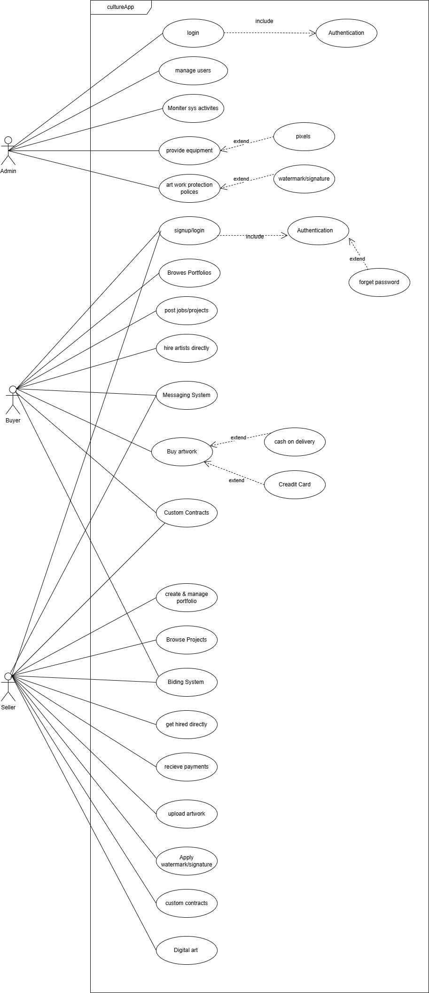

## Use Case Diagram:

**Chapter 4:**

**Class Diagram:**

**Description:**

A class diagram is a fundamental UML (Unified Modeling Language) tool used in software development to visually represent the structure of a system. It illustrates classes, their attributes, methods, and relationships (like inheritance, association, or composition) between objects. Class diagrams serve as a blueprint for developers, ensuring a clear understanding of the system’s architecture before coding begins. They promote modularity, reusability, and scalability by organizing code into logical components. By defining responsibilities and interactions early, class diagrams reduce errors, streamline communication among team members, and align stakeholders’ expectations. In agile projects, they evolve iteratively, adapting to new requirements while maintaining system integrity. Ultimately, class diagrams bridge the gap between design and implementation, saving time and effort during development.

**Diagram:**

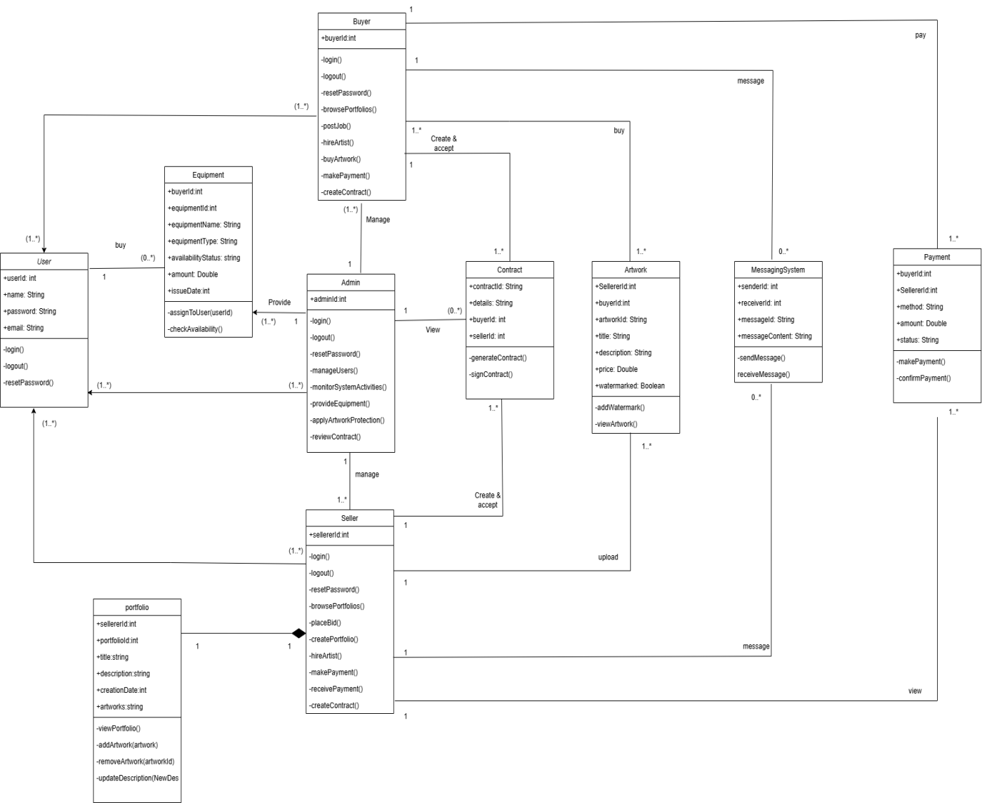

**domain diagram :**

**Description:**

A domain diagram (also called a domain model or conceptual class diagram) is a high-level visual representation of the key concepts, entities, and relationships within a specific problem domain. Unlike a detailed class diagram (which focuses on implementation), a domain diagram captures the business logic and real-world entities that the system must handle. It helps developers, analysts, and stakeholders:

* Understand the Core Business Concepts – Identifies essential entities (e.g., Customer, Order, Product) and their interactions.
* Clarify Relationships – Shows how different domain objects connect (e.g., "A Customer places an Order").
* Improve Communication – Bridges the gap between technical and non-technical teams by simplifying complex business rules.
* Guide Database & System Design – Serves as a foundation for designing databases, APIs, and business logic.
* Domain diagrams are especially useful in early project phases (requirements gathering, analysis) to ensure all stakeholders agree on the system’s scope before moving to technical design.

**Diagram:**

version 1

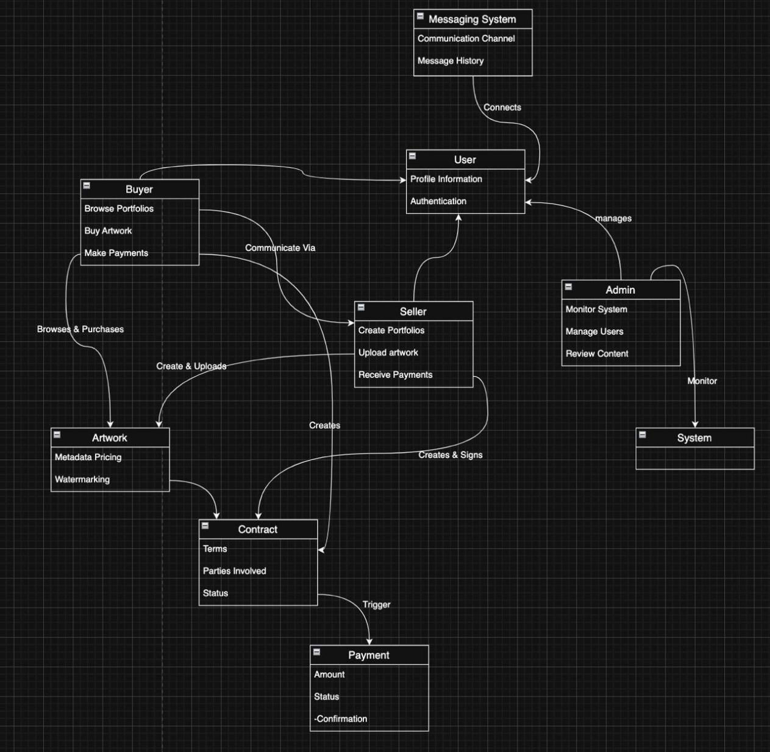

version 2

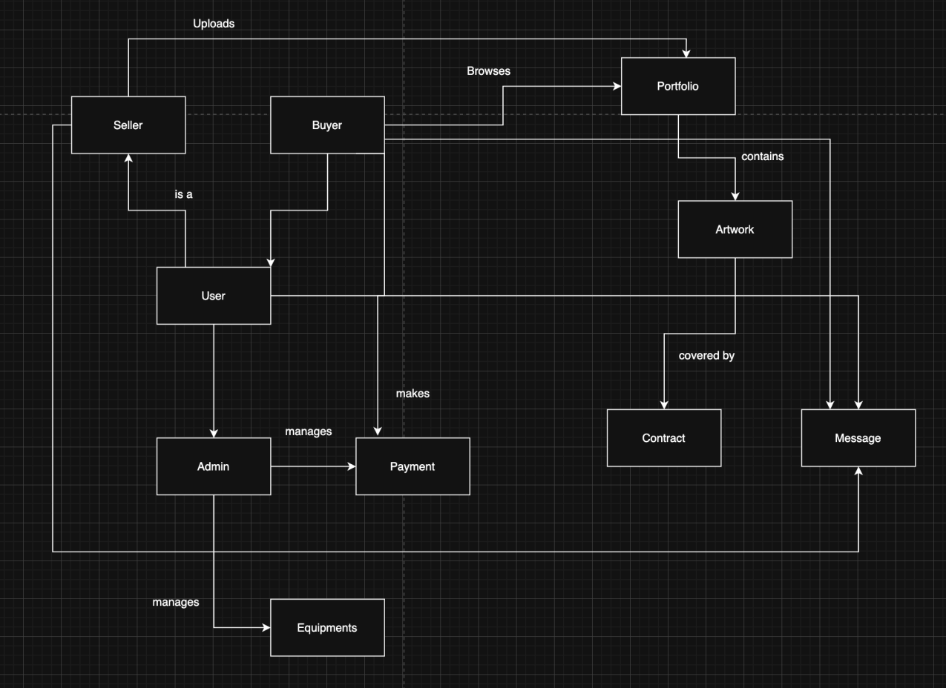

**ERD Diagram:**

**Description:**

An Entity-Relationship Diagram (ERD) is a visual representation of the data structure and relationships within a system. It is primarily used in database design to organize and define how data entities (like Customer, Product, Order) interact with each other. **Key Uses of ERD:**

1. Database Planning – Helps design tables, columns, and relationships (e.g., one-to-many, many-to-many) before coding.
2. Clarifies Data Flow – Shows how different entities (e.g., Student ↔ Course) are connected.
3. Reduces Redundancy – Ensures efficient data storage by avoiding duplication (normalization).
4. Improves Team Communication – Serves as a reference for developers, DBAs, and stakeholders.

**Diagram:**

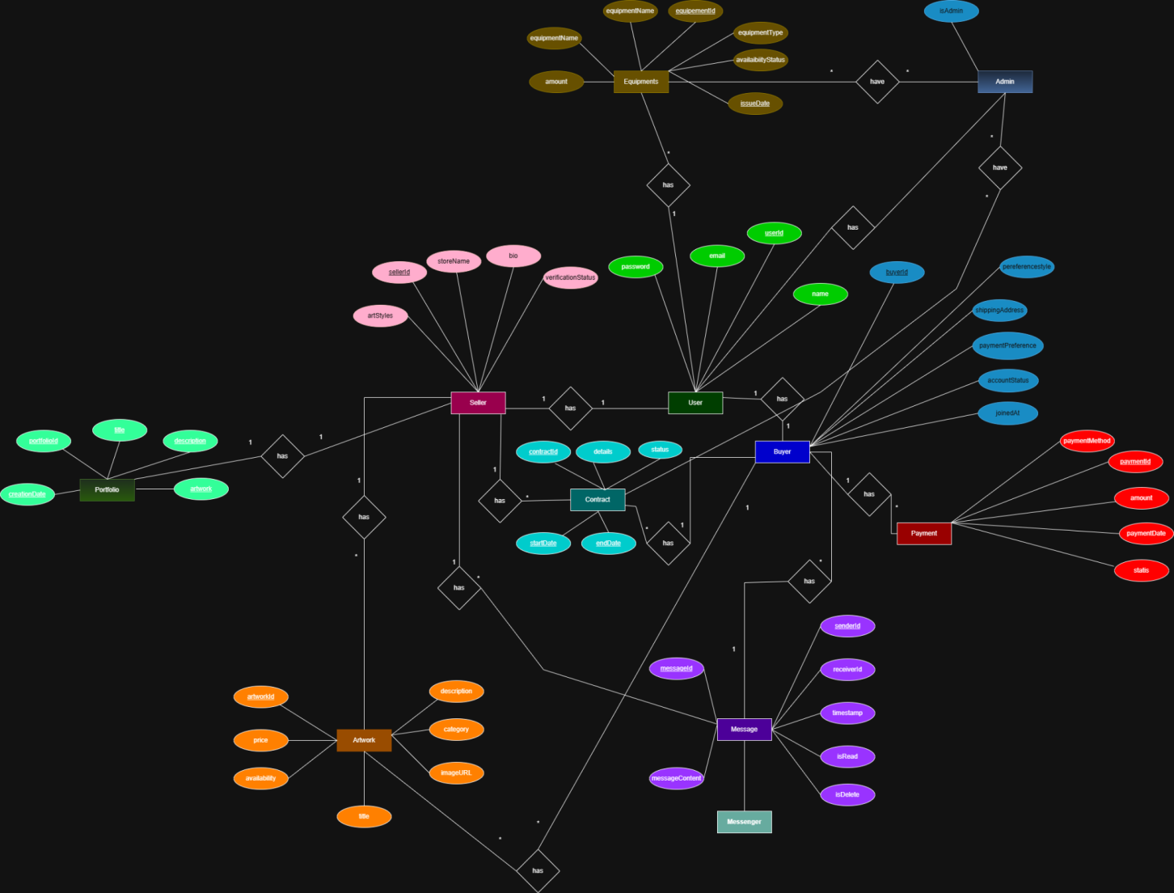

**Architecture diagram:**

**Description:**

An architecture diagram is a high-level visual representation of a software system's structure, showing how different components (like servers, databases, APIs, and microservices) interact with each other. It serves as a blueprint for developers, engineers, and stakeholders to understand the system's design, scalability, and flow of data.

**Key Uses of Architecture Diagrams:**

* System Design & Planning
* System Design & Planning
* Improves Team Collaboration
* Identifies Performance Bottlenecks

**Diagram:**

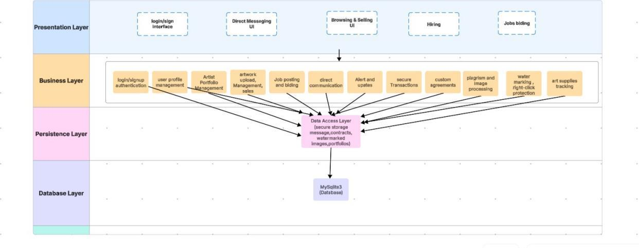

**Sequence diagram:**

**Description:**

A sequence diagram plays an important role in a software project by illustrating the dynamic behavior of the system — that is, how different objects (like users, system components, and external actors) interact with each other over time. It visually represents the flow of messages or actions in chronological order, helping developers understand the logical flow of operations. This diagram is especially useful for designing backend processes, clarifying how use cases are implemented, and planning test scenarios. Overall, it serves as a clear communication tool between developers, designers, and stakeholders.

**Squence Diagram in parts: Buyer:**

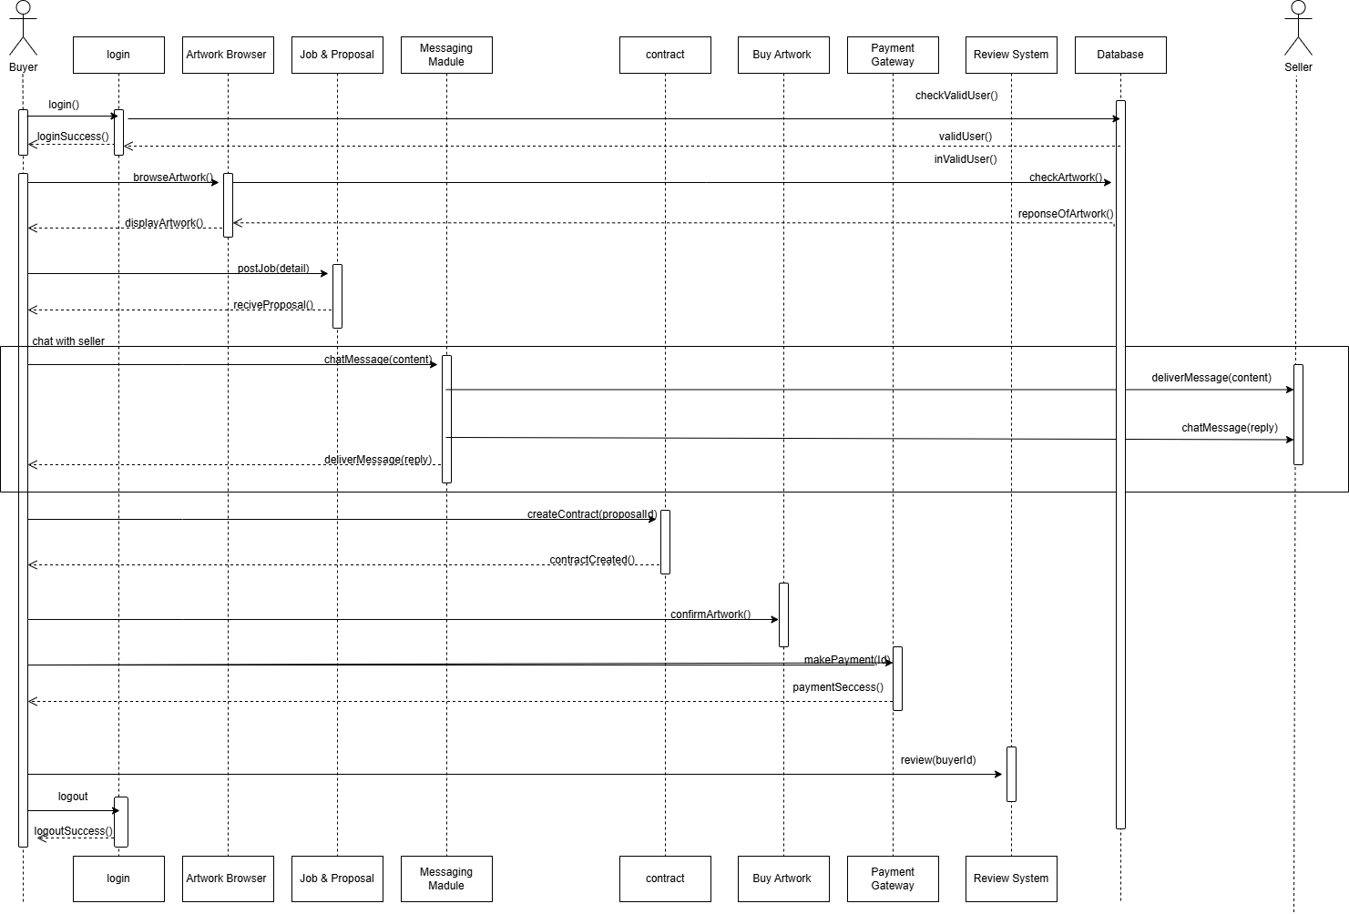

**Admin**

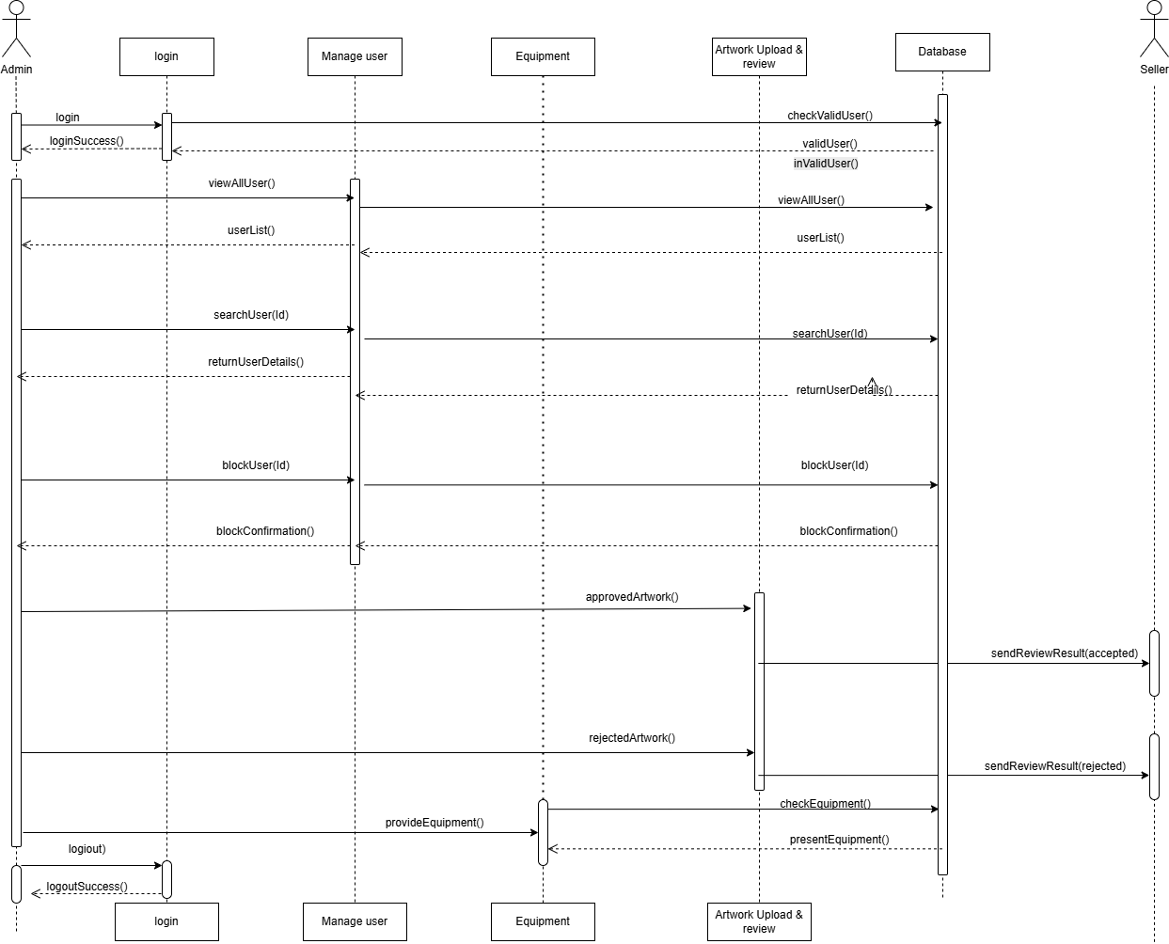

**Seller:**

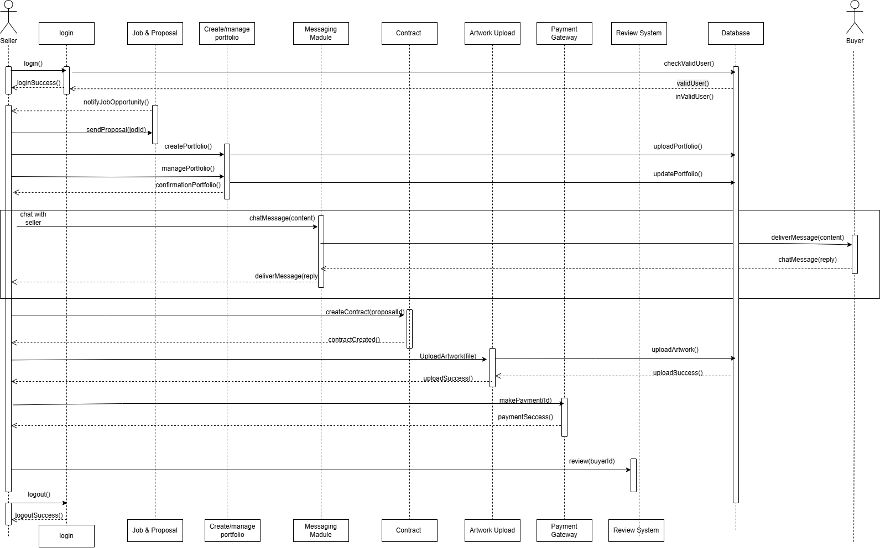

**Chapter 5:**

**Implementation​**

**5.1.​Important Flow Control/Pseudo codes​**

The core flow of the CultureUp application is to give a system to all artists to try to sell their work

**5.2.​Components, Libraries, Web Services and stubs​**

Frontend (React):

* react-router-dom: for client-side routing
* axios: for HTTP requests
* tailwindcss: for UI styling
* framer-motion: for animations
* Custom components: ImageGallery, PromptInput, ResultDisplay, UserDashboard

Backend (Python):

* Framework: Flask (or Django if that’s used)
* sqlite3: built-in DB support

**5.3.​Deployment Environment​**

Frontend: Hosted on Vercel or Netlify (React build)

Backend: Hosted via Render, Railway, or Heroku (Flask/Django app)

**5.4.​Tools and Techniques​**

React Developer Tools and Redux DevTools (if Redux is used)

Postman or Insomnia for testing backend APIs

VS Code with extensions for Python, React, Prettier, ESLint

Git + GitHub for version control

AI Prompt Engineering: technique used to refine results for paintings and designs

Responsive Design: Using Tailwind’s utility-first classes

Basic CI/CD: Vercel auto-deployment from GitHub for frontend

**5.5.​Best Practices / Coding Standards​**

Frontend (React):

* Components organized by feature/module
* Functional components with hooks (useState, useEffect, useContext)
* PropTypes or TypeScript (if used) for prop validation
* DRY principle and code reusability for components

Backend (Python/Flask):

* RESTful API design
* Separation of concerns (routes, services, models)
* Proper exception handling
* Input validation and sanitization
* Clear naming conventions and docstrings

General:

* Consistent code formatting using Prettier and Black (Python)
* Followed PEP-8 (Python) and Airbnb Style Guide (JS/React)
* Modular code structure and reusable logic
* Comments and documentation for all major functions and logic

**5.6.​Version Control**

We are using Github.

### **Chapter 6: Software Testing Documents**

**6.1. Introduction**

Testing is a critical phase in the software development lifecycle, ensuring that the CultureUp.pk application performs as intended and meets user expectations. The primary goal of testing is to identify and correct defects before deployment. The testing process focused on verifying functionality, usability, performance, and security across all modules including user authentication, Create Porfolio, Manage Portfolio, Upload Artwork, Bidding, Equipment, job post, get Job and notification system. A combination of manual and automated testing techniques was applied to validate the app’s behavior against the defined requirements in the Software Requirement Specification (SRS).

**6.2. Test Approach**

The testing of CultureUp.pk followed a Black Box Testing Approach, focusing on verifying functionality based on expected user behavior without analyzing internal code logic. Since development followed the Work Breakdown Structure iteratively, each module was tested after implementation to ensure feature reliability.

**The testing approach included:**

**Unit Testing:**

Individual functions, UI components, REST APIs, and database operations were tested independently

(e.g., login validation, job posting form validation, artwork upload, bidding conditions).

**Integration Testing:**

Combined system components were tested, such as:

User authentication communicating with database

Artwork upload interacting with image storage + watermarking

Job posting → bidding module → hiring workflow

**System Testing:**

End-to-end user flows were tested across all roles:

Artist experience

Buyer experience

Admin experience

This ensured complete workflow and business logic correctness.

**User Acceptance Testing (UAT):**

Conducted with real users including:

15+ test artists

15+ test buyers

to verify usability, responsiveness, clarity of UI, and real-world functionality.

**6.3. Test Plan**

**6.3.1 Features to be tested**

The features of the CultureUp system that were included in testing are:

User registration and login authentication

Artwork posting & display

Apply watermark / artist signature

Seller & Buyer messaging system

Freelance job posting & bidding

Artist hiring workflow

Checkout system

Payment method processing

Admin controls (user management, removal, moderation)

Search & filter options for artworks and jobs

Email notification system

**6.3.2. Features not to be tested**

For this release, the following features are not included in testing:

100% accuracy of plagiarism-detection algorithm for images

Automatic watermark removal protection beyond default algorithm

Application behavior on extremely outdated browsers (Internet Explorer, etc.)

Full compatibility with all mobile screen sizes (minor UI variations acceptable)

Offline-mode functionality (system requires internet)

**6.4. Testing Tools and Environment**

**6.4.1. Testing Tools**

The following tools and platforms were used during the testing phase:

Postman — API functional testing

SQLite Studio — database validation and relationship checks

React Testing Library — frontend component testing

Django Test Framework — backend unit testing

GitHub Issue Tracker — bug reporting & monitoring

Browser Developer Tools (Chrome) — UI debugging & console error tracking

**6.4.2. Testing Environment**

The application was tested in environments closely resembling real-world deployment conditions:

Frontend Platform: ReactJS

Backend Platform: Django (Python)

Database: SQLite3

**Operating Systems Tested:**

Windows 10 & 11

**Browsers Tested:**

Google Chrome

Microsoft Edge

**Hardware Devices:**

HP Core i5 laptop

Some other

**Network Requirements:**

Normal home internet

4G mobile internet testing

**Testing Types Performed:**

Unit Testing

Integration Testing

System Testing

**6.5. List of Test Scenarios**

Test Cases include a lot of steps, conditions, and inputs that can be used while performing testing tasks. The main goal of this action is to guarantee whether an application passes or fails as far as its functionality and other aspects. Following are the test cases of CultureUp.pk Application.

**Test Cases**

**Signup Page**  
Test Case Signup -1 Load Signup Page  
**Steps:**  
Open the Signup page.  
Expected: Signup form appears with all required fields.

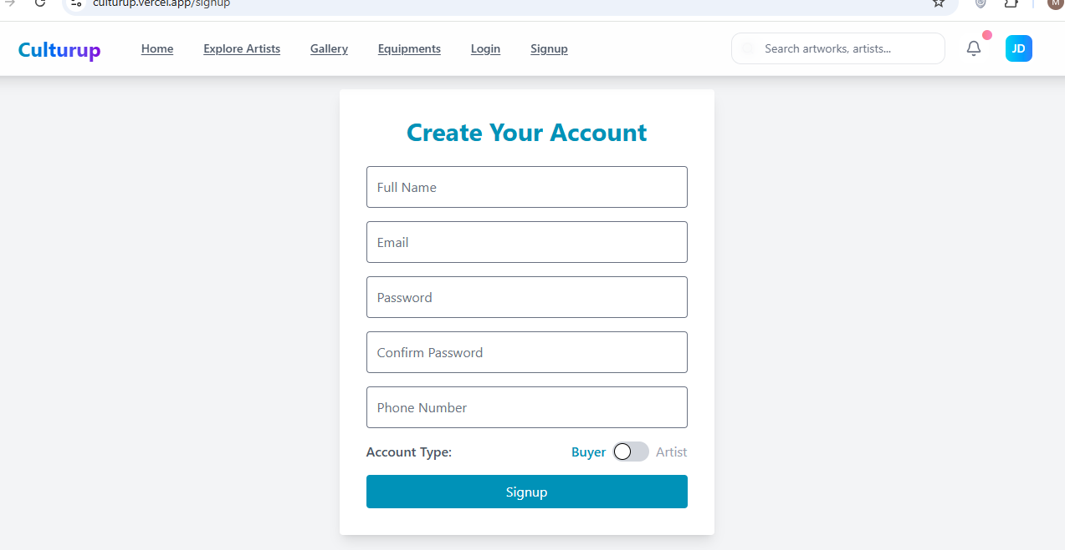

Test Case Signup -2 Successful Signup

**Steps:**

Enter full name.

Enter valid email.

Enter valid password.

Click Signup.  
Expected: User account created Redirect to Dashboard.

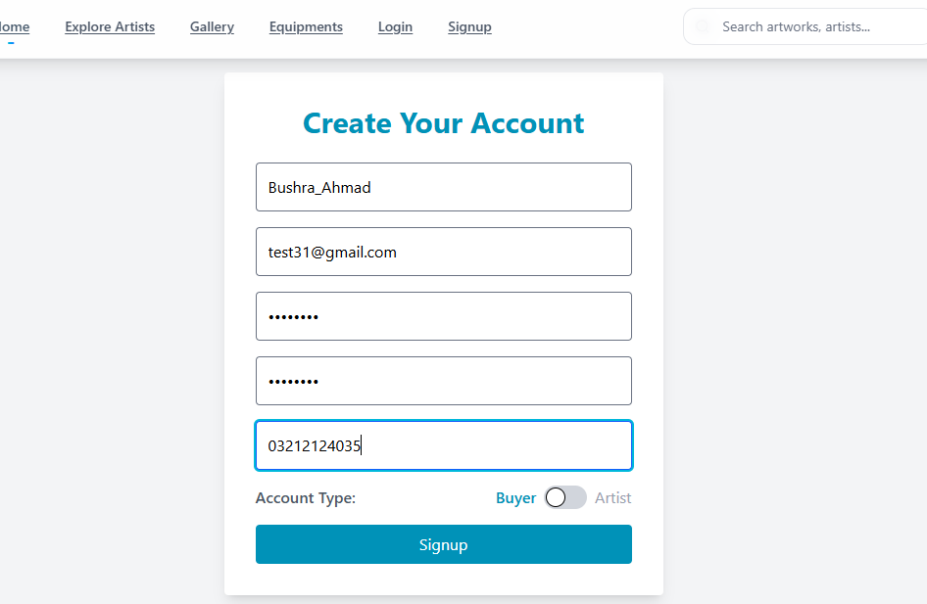

Test Case Signup -3 Required Fields Validation

**Steps:**

Click Signup without entering anything.  
Expected: Validation errors for all fields.

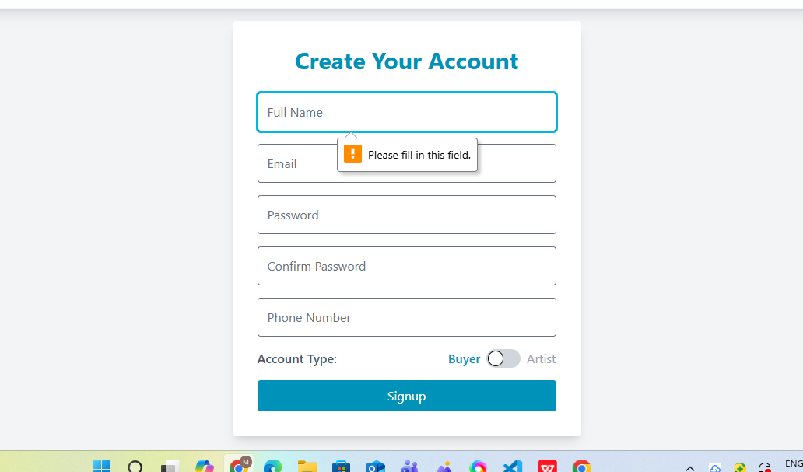

Test Case Signup -4 Invalid Email Format

Expected: “Invalid email address” error.

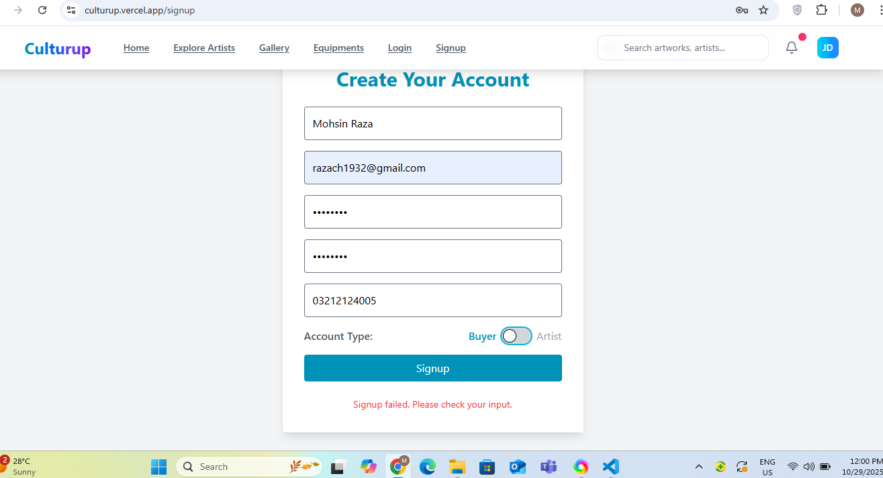

**Login page**

Test Case Login -1 Load Login Page

Expected: Email + Password fields visible.

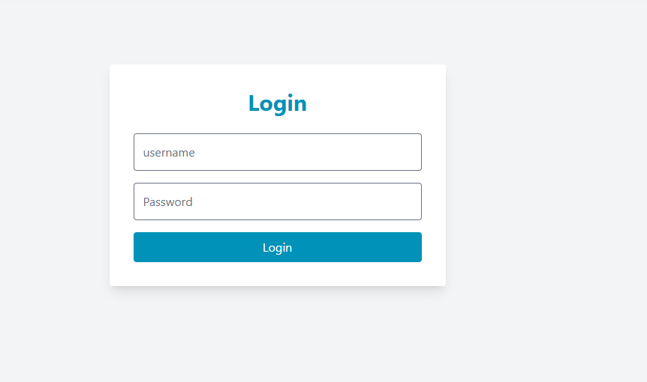

Test Case Login -2 Successful Login

Expected: Redirect to Dashboard.

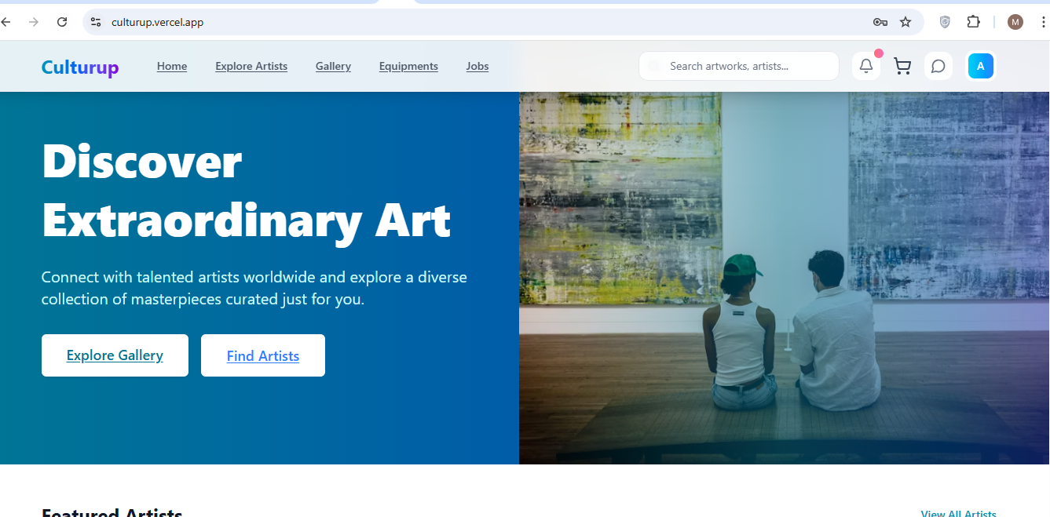

Test Case Login -3 Wrong Password

Expected: Error: “Invalid credentials”.

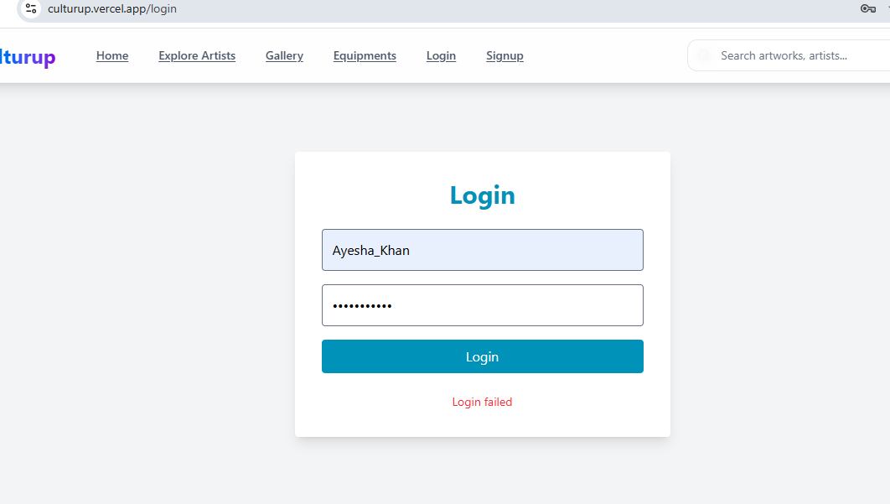

Test Case Login -4 Empty Fields

Expected: Required field validations.

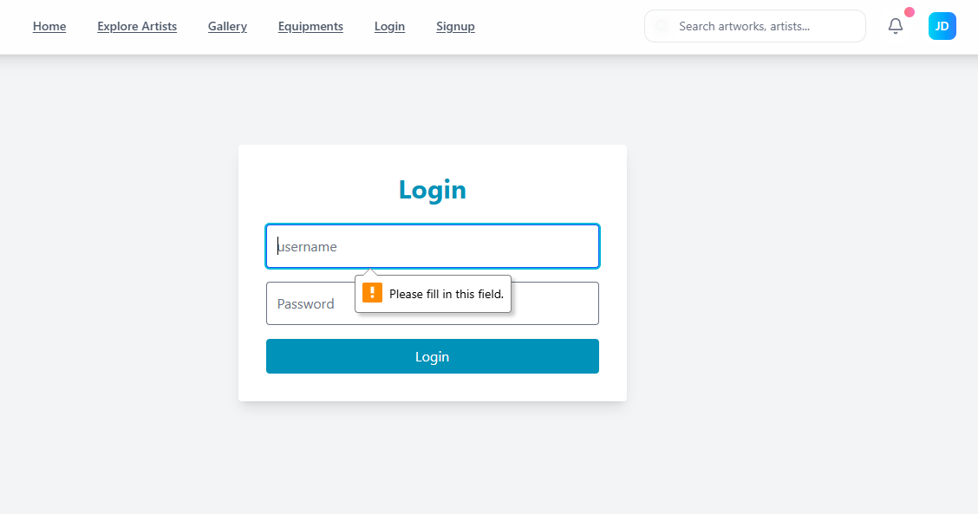

**USER MODULE**

**Dashboard page**

Test Case Dashboard -1 Dashboard Loads home page

Expected: Welcome special message, quick links and Nav bar features.



Test Case Dashboard -2 Navigate to Explore

Expected: Featured Artist page opens.

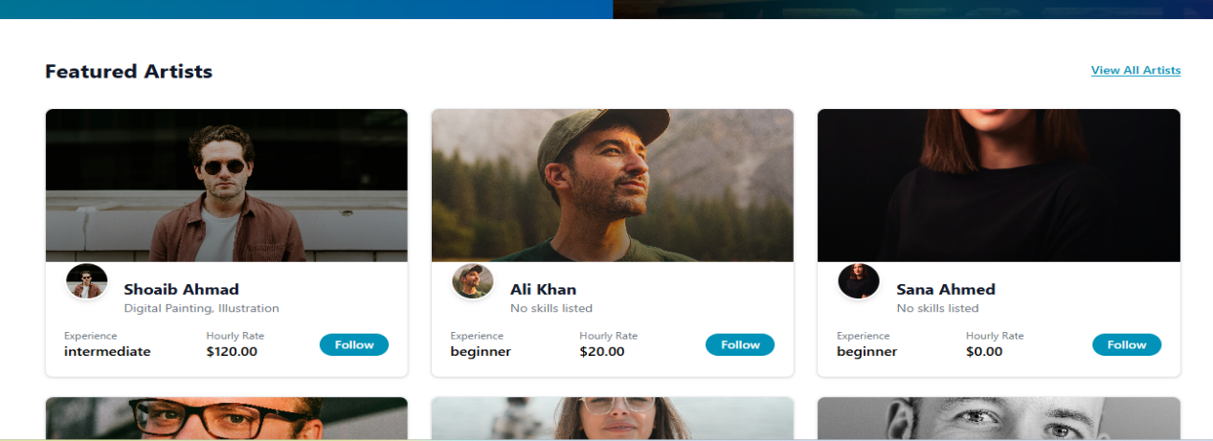

Test Case Dashboard -3 Recent Artworks component loads

Expected: Recent artworks section displays items.

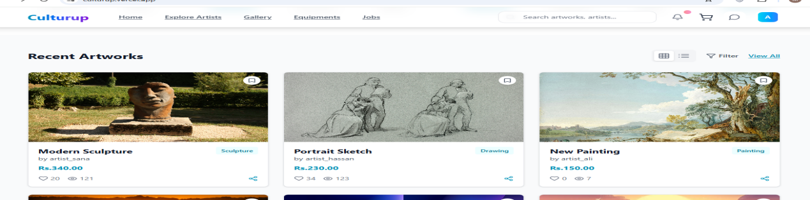

Test Case Dashboard - Popular Categories component loads

Expected:Popular Categories section displays items.

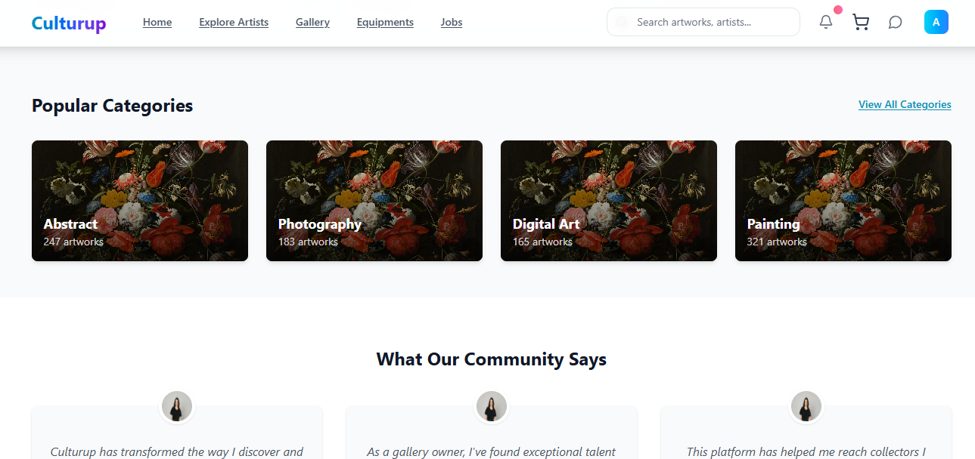

**Explore Gallery page**

Test Case Explore Gallery -1 Explore Gallery Categories Load  
Expected: Explore Gallery Category cards visible.

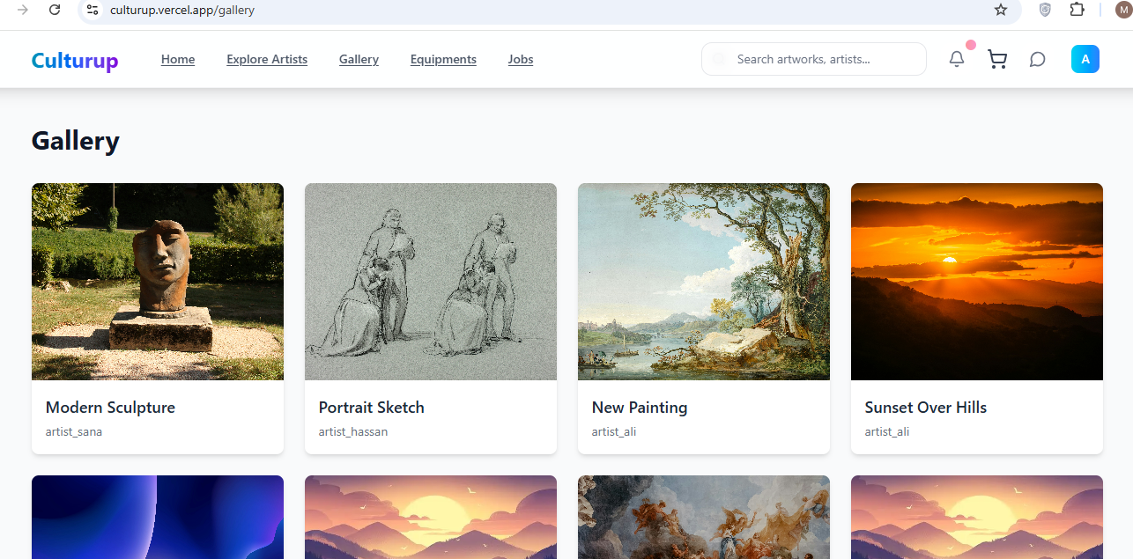

**ExploreArtists page**

Test Case ExploreArtists-1 List of Artists Loads

Uses component: FeaturedArtists / ArtistCard  
Expected: Artist cards displayed.

Test Case ExploreArtists-2 Clicking Artist → ArtworkDetailPage / Profile

Expected: Detailed artist portfolio appears.

**Profile page**

Test Case Profile-1 Load Artist Profile

Expected: Artist bio, images, social/contact visible.

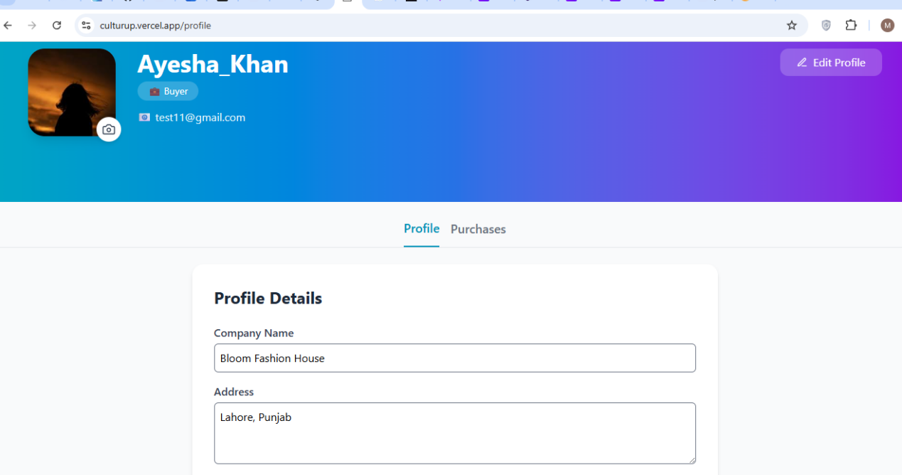

Test Case Profile-2 Artwork

Uses: ArtworkDetailPage

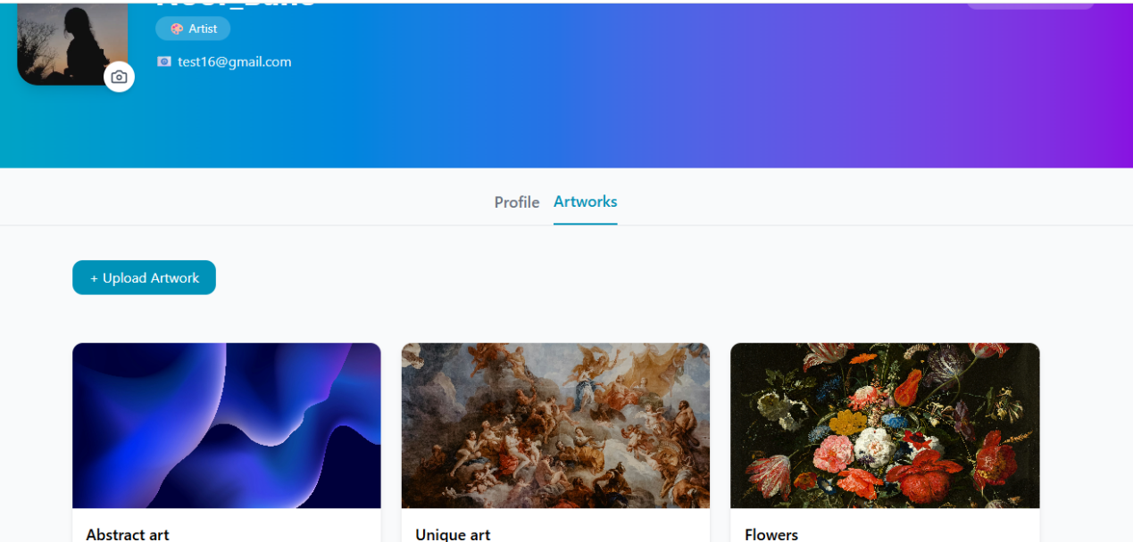  
Expected: Clicking opens detail view.



**Gallery page**

Test Case Gallery -1 Gallery Items Load  
Expected: Grid of artworks appears.



Test Case Gallery -1 Open Artwork Detail

Expected: Full detail modal/page opens.

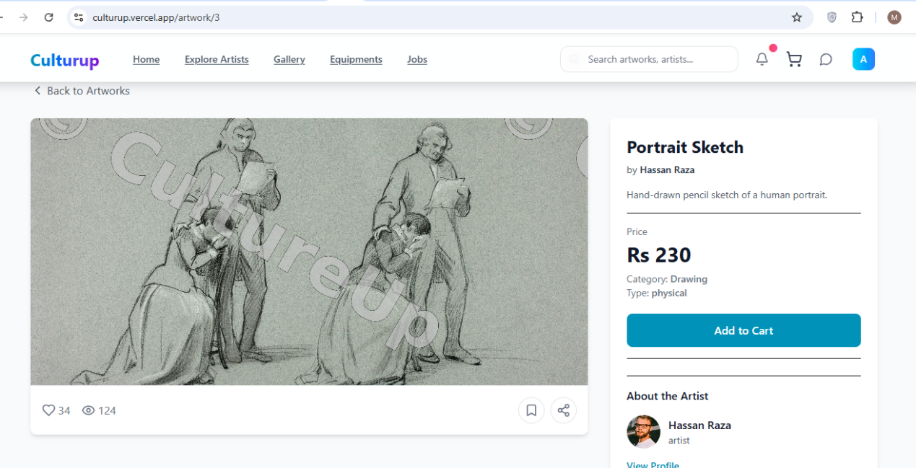

**ADMIN MODULE**

**AdminLogin page**

Test Case AdminLogin-1 Load Page

Expected: Admin email/password fields.

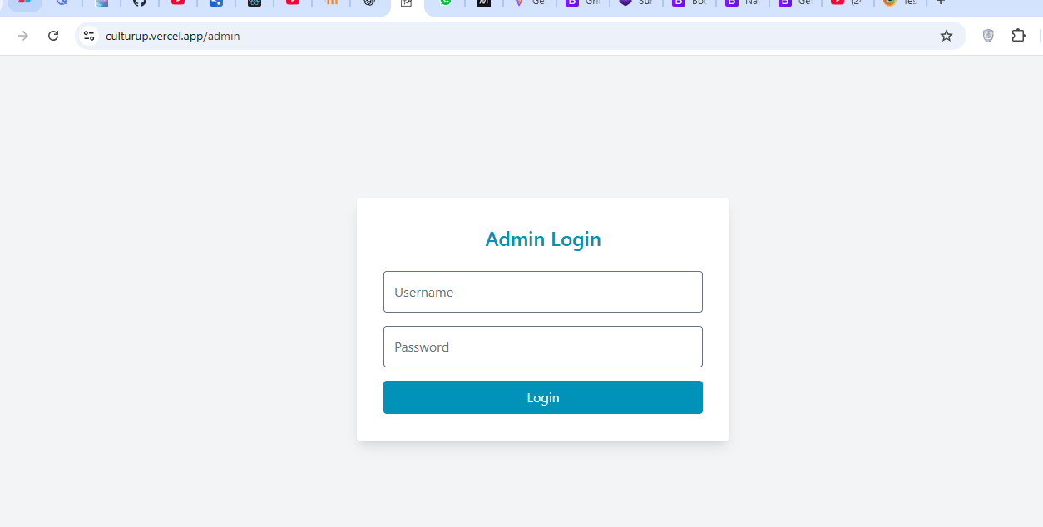

Test Case AdminLogin-2 Valid Admin Login

Expected: Redirect to AdminDashboard.

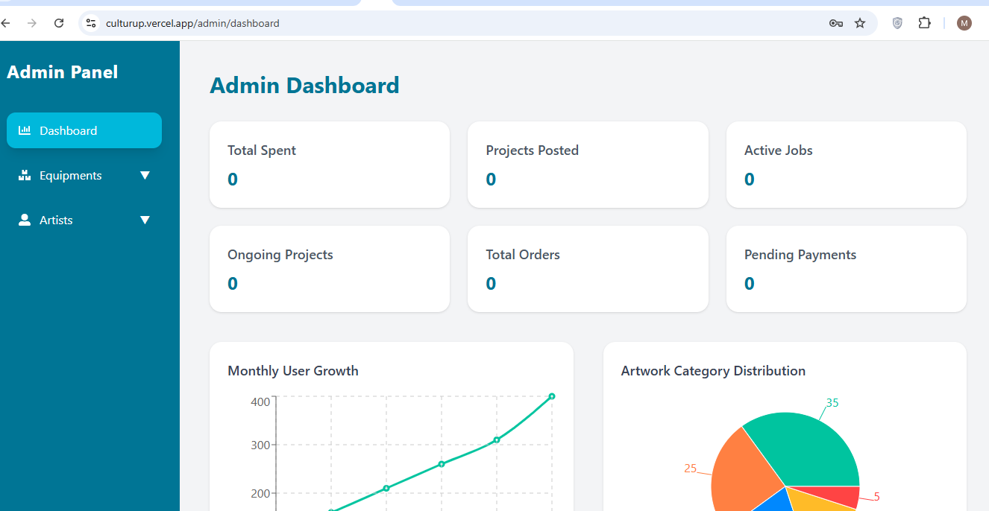

Test Case AdminLogin-3 Invalid Admin Credentials

Expected: Unauthorized error message.

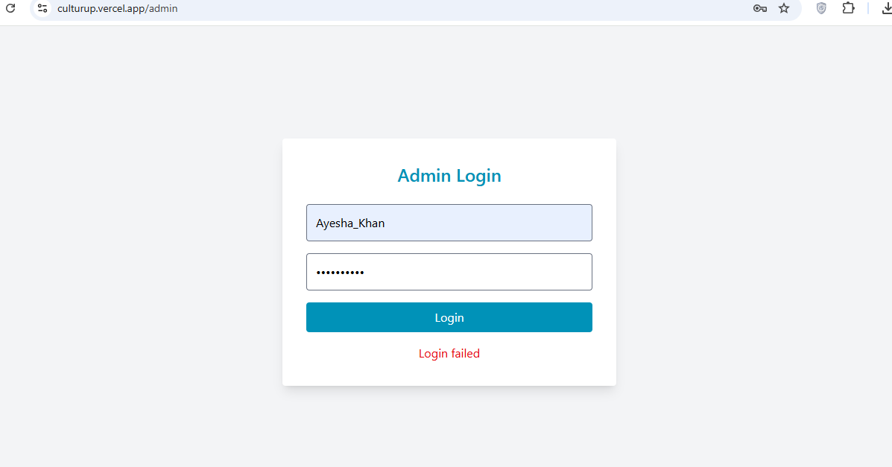

**ArtEquipment page**

Test Case Equipment-1 Equipment List Loads

Expected: Items with images and titles shown.

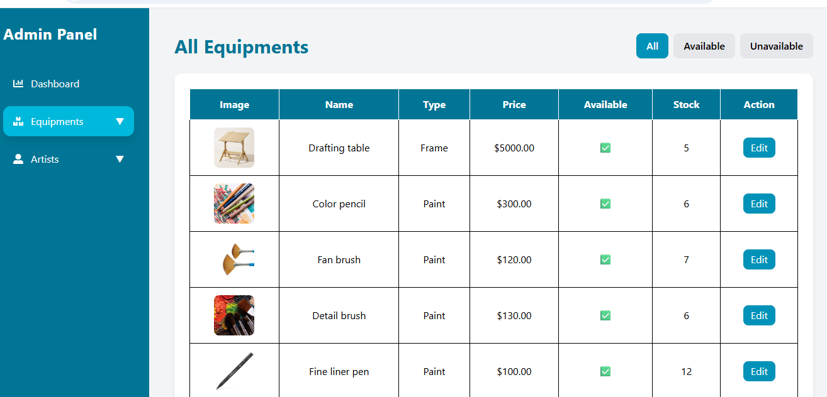

Test Case Equipment-2 Click Create Equipment Item

Expected: Equipment detail.

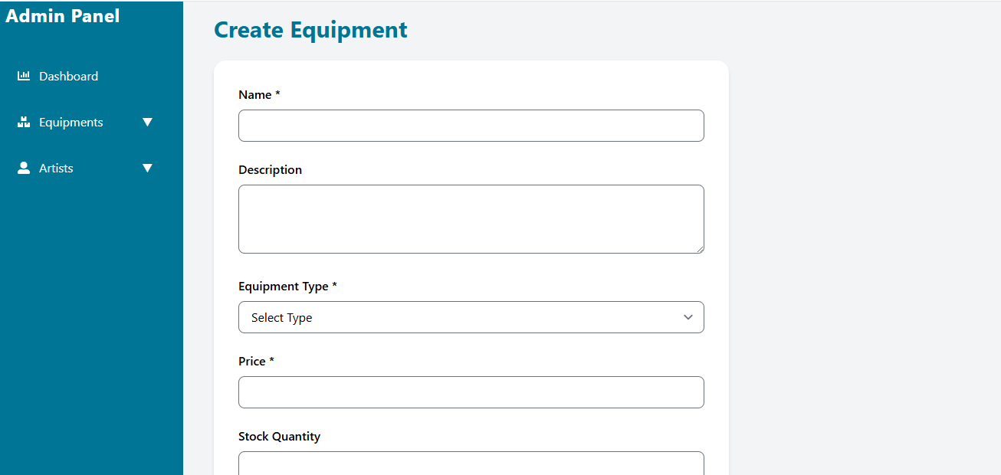

# Chapter 7

Summary:

Cultureup.pk is Pakistan’s first freelancing and e-commerce platform dedicated to artists, providing them with a space to showcase their work, gain exposure, and earn appreciation. It’s a hub for unique, handcrafted, and vintage treasures from around the world.

Conclusion:

CultureUp.pk is Pakistan’s first dedicated digital platform that offers artists freelancing, e-commerce, and art protection all in one place.This platform addresses all the issues present in the traditional art market such as lack of recognition, difficulty in earning, risk of plagiarism, and challenges in reaching clients.

Future Enhancements:

In the future, CultureUp.pk will be developed into an even more powerful, scalable, and nationwide art ecosystem.

The platform’s upcoming goals will include:

Mobile Application Launch

International Marketplace Expansion

Artist Training & Workshops

Artist Community & Events